NAME: 1_________, 2___________

WRITING AN EFFECTIVE CONCLUSION:

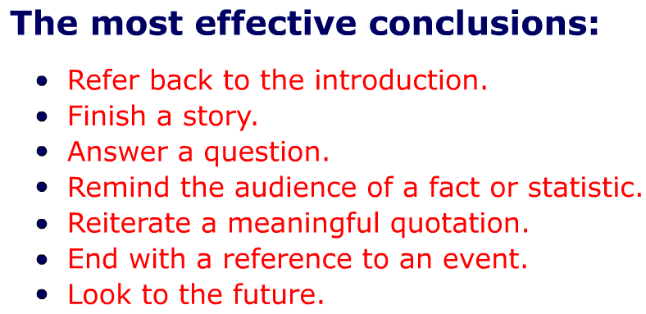

SAMPLE:

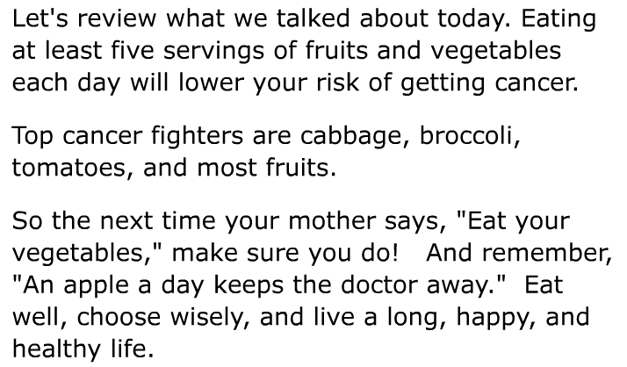

 | yes | no

