Writer’s Workshop
Learning Intention: to gain a deep understanding of the different aspects of the writing process and apply it to your writing so that you build your skills in the 6 traits of writing.
Tick the boxes as you go.
AIM: You will build up a writing folio of different types of writing pieces. Follow the writing process:

TASK 1: Brainstorm 10 things you love/like
TASK 2: Brainstorm 5 things you would change about the world.
TASK 3: Select one topic from one of your lists above.
TASK 4: Brainstorm writing ideas for your topic. See the Chupa Chup and Batman examples:
Consider: a story about… a poem about… a persuasive piece arguing that… instructions on… advice about… a description of… an informative piece about…
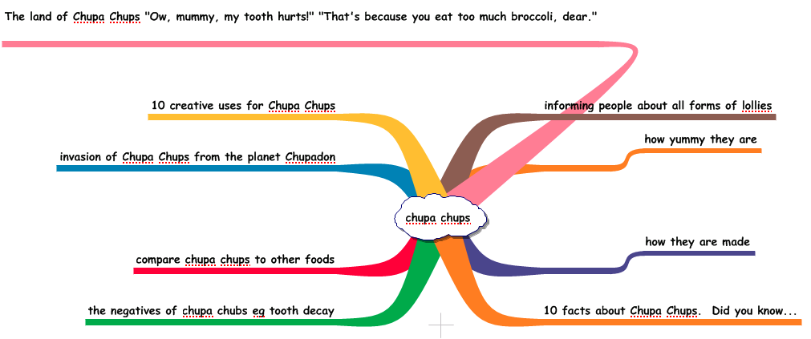

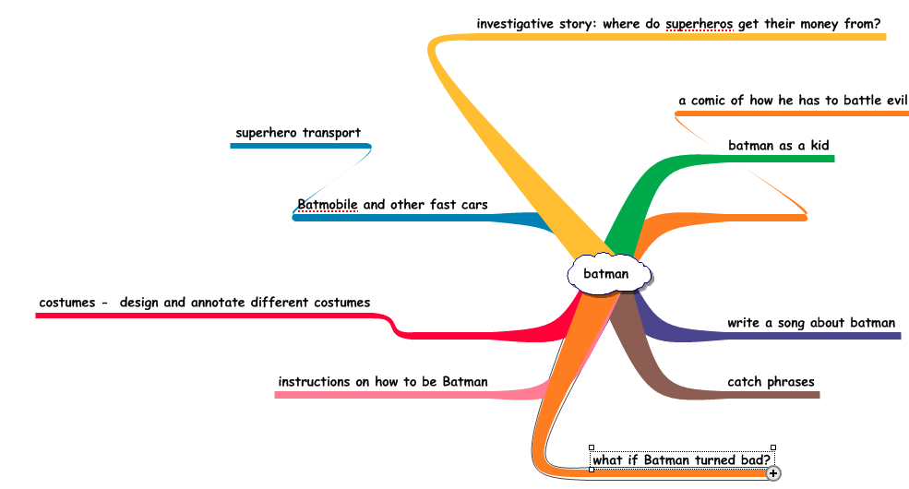

TASK 5: Either start your draft straight away, or do further planning/brainstorming.
TASK 6: Revise – Start with the Revision Checklist at the end of this handout. Word Choice, Sentence Fluency, Voice, Organisation
TASK 7: Edit – Conventions
TASK 8: Publish!

Literary Language Techniques

Imagery – Pictures poets create with words that appeal to our five senses, such as tangy lemon, scented garden, cozy blanket, glowing sunset, angelic voices, etc.
Simile – When a writer points out a similar quality in two things that seem to be unlike, using like or as, “His head is as hard as a rock.” or, “She cries like a baby whenever I look at her.”
Metaphor – When a writer suggests a similarity between two generally unlike things. A metaphor does not use like or as. If a test was easy, you may say, “It was a piece of cake.”
Personification – Giving human qualities to objects or ideas. Phrases that use personification include: “biting cold,” “howling wind,” and “smiling sun.”
Symbol – A symbol is anything that stands for or represents something else. Symbols are usually concrete objects or images that represent abstract ideas. (The eagle represents freedom; the flag represents support for the U.S.)
Allusion – An allusion is a reference to a well-known person, place, event, literary work, or work of art. The Bible and classical mythology provide two of the most common sources of literary allusions.
Theme – A poet’s message about life.

Sound Devices or Patterns

Alliteration – It is the repetition of the initial consonant sound at the beginning of words (e.g.) “Peter Piper picked a peck of pickled peppers,” repeats the p at the beginnings of words.
Onomatopoeia – It is the use of words that imitate sounds. Words like buzz, hiss, and screech are examples.
Assonance – Similarity of sound between words or syllables of vowel sounds, (pale/brave), but
not of the consonants.
Repetition – repeating words or phrases in a specific and effective way.
REVISION CHECKLIST

Focus on one target skill at a time. Read the item and then go back and read
your piece for each item. Make sure your piece is exactly how you want it
for each item. Remember, revision is the MOST important step in writing.

SCORE YOURSELF OUT OF 10
Shade across to the score you give yourself
 | 1 | 2 | 3 | 4 | 5 | 6 | 7 | 8 | 9 | 10
1. Do I have an opening sentence(s) that hooks the reader? ____
2. Is my piece focused? Does it stick to the topic throughout the piece? ____
3. Is my piece clear? Does it say what I want it to say? Do my sentences and ideas make sense? Flow? ____
4. Have I completely answered all the questions asked in the prompt? Refer back to prompt to check. ____
5. Have I included details, explanation, and elaboration of my ideas? ____
6. Do I have a closing sentence(s)? Does it close and tie up the piece? ____
7. Do my sentences show rather than tell? ____

8. Do I have a varied word choice? ____

9. Do I have a varied sentence structure (questions, exclamations, dialogue, one word sentences, variety of length)? ____
10. Do I have transition words? ____

11. Do I use compositional risks? (italics, simile, metaphor, personification, onomatopoeia, repetition, alliteration, etc)? ____
