Why did soldiers volunteer to go to War?
When war broke out Australia was not an independent country like it is today. It was a part of the British Empire. As Britain was at war against Germany and its allies, Australia was also automatically at war. Each man had to choose whether to enlist and go to the war or not. A very large number of men (and some women) volunteered to go overseas- about 416,000 people enlisted out of a population of about four and a half million, and 331,000 of these served overseas. Many of these joined up straight away. Some did not, and there were many recruiting appeals during the war to encourage those people to enlist.
Here are two posters that were made to try to persuade people to join and fight.
TASK 1: Discussion questions:
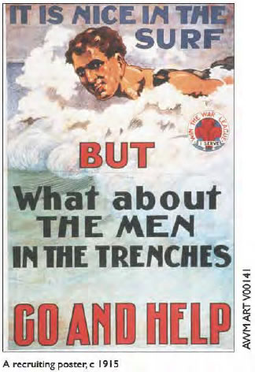
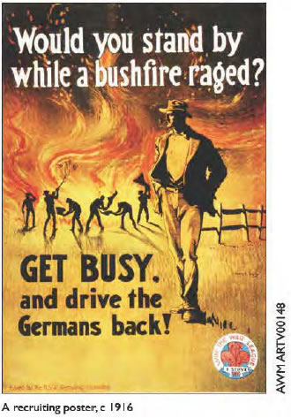
- What does the poster show?
- What is the setting or context of the poster (e.g. in Australia, at war, etc.)?
- Who are the people in it? Why are these people in it?
- What are they doing or saying?
- What is the main message that the poster is giving about why you should join?
- Who is the poster meant to persuade?
- What has the artist done to get you to accept the message?
- Would this poster be likely to make a person join to fight? Why or why not?
TASK 2 - Match each poster to the main idea that it is trying to get across - either:
- patriotism
- mateship
- duty, or
- protecting others
Poster ___________is mainly about____________ Poster ___________is mainly about_______________

TASK 3: Match the reasons that men gave for deciding to go to war to the summary words under the heading.
Reasons for men deciding to go to war
  - Loyalty to Britain and the Empire - Duty - Shame - Mateship - Adventure –
  - Money - Romance and glory - Patriotism to Australia -
a) I went to war because the school books taught me it was a romantic thing - drums, uniforms, marching and glory
b) I wanted to stop the enemy - I believed they were cruel and savage
c) I joined because I could not have looked people in the eye if I hadn't - I would have been a coward
d) I joined because I thought it would be a chance to get away from the farm and see the world
e) I joined because it was every Australians duty to defend old Mother England where we had originally come from
f) I joined because there was a drought and I had no work - and the pay was good
g) I joined because Australia had to do her bit and show the world she was a great young nation
h) I joined because my mates did - I wanted to stay with them
Look back at the posters. Select a poster for each person that is closest to the reasons they gave for volunteering:
- Person A's reason is closest to Poster_____
- Person B's reason is closest to Poster_____
- Person C's reason is closest to Poster_____
- Person D's reason is closest to Poster_____
- Person E's reason is closest to Poster_____
- Person F's reason is closest to Poster_____
- Person G's reason is closest to Poster_____
- Person H's reason is closest to Poster_____
Not every man who could have gone to war volunteered to go. Suggest some reasons why an eligible man might have decided not to go to war. For example, they might have been opposed to war, or they had a family to look after, or they did not want to get injured.
How do you think other people in Australia who supported the war might have felt about the men who did not volunteer? Explain your reasons.
As the war progressed it generally became harder to raise the numbers of volunteers needed to replace the casualties suffered by the soldiers overseas. Recruiting campaigns and appeals became a significant part of Australian society.
TASK 4: Select one of the below recruitment strategies or responses. Study the materials and answer the accompanying questions.
- Badges
- Recruitment meetings & marches
- Recruiting posters
- Women & Recruiting
- Letters from Vera
- Reasons for not enlisting

Badges
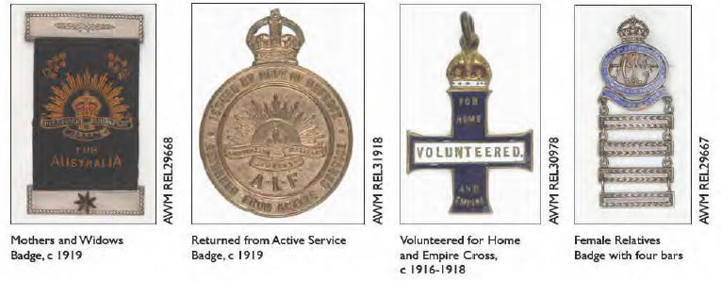
Describe the message of each badge.
- Why would people want or need to wear these badges during the war?
- What do these badges tell you about the values of the wearer?
- What do the existence of these badges suggest about the unity of the society at the time?

Recruiting meetings and marches
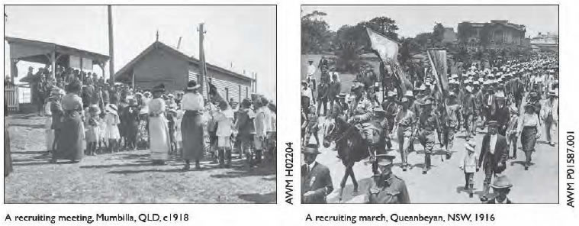
- Who would such recruiting meetings be for?
- Who is present at this one?
- What impact might this have on recruiting?
- What impact might it have on a small community?
- Why might some men be tempted to join this march?
- What impact might this have on recruiting?
- What impact might it have on a small community?

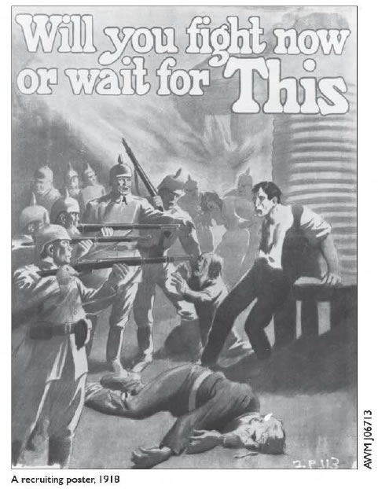
Recruiting posters
For this poster decide:
- What does the poster show?
- Why does it focus on those particular people?
- What does the artist think about the men who have volunteered?
- What does the artist think about men who have not volunteered?
- What does the artist think of the enemy?
- Do you think this was likely to have been an effective appeal? Why?
These posters were sponsored by a government that wanted to persuade citizens to accept a certain duty. Is this an appropriate role for a government in wartime?
These posters not only urge men to join - they also make judgements about the men. Do you think these posters were more likely to unite or divide society? Explain your reasons.
Were men who did not want to enlist unpatriotic? Explain your ideas.

Women and recruiting
Here are some cards that were handed out to people.
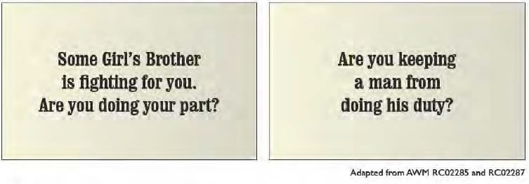
Consider these questions for each card:
- Who would hand out these cards?
- Who is the 'target' audience in each case?
- What are they trying to achieve?
- What is their method of persuasion?
- Are they likely to be effective?
- Would many women be prepared to be involved in this activity? Explain your reasons.
- Do you think these cards would have united or divided society? Why?
- Do you think such campaigning is appropriate in wartime? Explain your reasons.

Letters from Vera
Here are extracts from two letters printed in 1916 in a small Victorian country newspaper, the Upper Murray and Mitta Herald, during a period of recruiting campaigns. We do not know if they are genuine letters from a real person, or ones that were deliberately 'faked' to get a message across at the time. Either way they are an interesting view of some people's attitudes and values at that time. (As quoted in John McQuilton, Rural Australia and the Great War, Melbourne University Press, 2001, pages 129-30)
Dear Bob
I am a lonely country girl, and want a man to fight for me. The recruiting sergeant said your girl won't let you go ... I intend visiting Walwa soon, and I know that, as soon as you see me, you will reckon I am worth fighting for. I will be your dinkum girl and you will get into khaki at once and put-up the fight of your life. If you accept my offer, Bob, you must hot speak to that unpatriotic black-eyed cat again ... Bob, I just want to stir your patriotism, because I know that, when you realise that your country and all the nice girls need your help to fight for our freedom, your courage will be there, and that you will prove to be like those thousands who have made Australian bravery a world-wide topic of praise. And when you are gone, dear Bob, I will not be unmindful of you.lt will be the joy of my life just to think you are gone to take part in the fight for freedom and our race ... Trusting you will at once take the manly step, I remain your own little woodland dove until the end of the war and for months after.
Vera
Dear Bob
Don't the boys look nice when they come up and say Good-bye to the girls, who are so proud to see the soldier boys in Khaki? Well, Bob, I was at the concert. Can't theWalwa girls sing? What an enthusiastic welcome home they will sing to the boys when the war is over, and they return with their medals hanging on their manly bosoms. The man who stayed at home will not get a look-in! He will then wish he had enlisted, and will feel that he had rather died a hero fighting on the rock-clad slopes of those who have won distinction. What about the two able delinquents who sang 'Keep the Flag Flying'? Didn't they get hen-pecked after the concert by the noble mothers whose brave sons are already keeping the old flag flying ... Bob, dear, I can't believe there is a wilful shirker Australian born. A man may have substantial reasons why he has not already enlisted. I am more than ready to attribute it to a want of resolution or a want of realization of the awful possibilities hanging over us ... But, oh, the sight of about ten men sitting on a·fence! .. . as .soon as they sighted the [recruiting] sergeant, they one and all dived into their dug-outs in a haystack close by .. I induced [your mother] to sign the consent form to enable you to enlist; this I am forwarding by post. Now, Bob, do the manly act, there's a dear. Any other reason now would be a cloak for cowardice. I am sending two nice little flags to the men who sang 'Keep the Flag Flying', and I hope they will soon realize that it is their duty to go out and fight for it, and leave the singing to the girls of Walwa ...
Vera
- What is Vera trying to do?
- What is her expectation of men?
- Why does she believe that men should enlist?
- How does she regard anyone who does not share her values?
- What examples are there in these letters of other pressure being put on men to enlist?
- What examples are there of pressure applied to other women?
- What do these letters suggest about the impact of recruiting campaigns on Australian society at the time?

Reasons for not enlisting - Conscription exemption court hearings
In 1916 Prime Minister 'Billy' Hughes could conscript every 'eligible' man into the army, but he could not make them serve overseas without changing the existing law. Hughes believed he could change the law, and while that was happening he called up men to go into camp and start their training. People who thought they should not go into camp had to justify that in a special court. Here is a newspaper report of a court hearing in which men who were seeking to be exempt from the call-up explained their reasons.
Henry Edge (33), cartage contractor, on the ground that he was unfit for active service, because of weak eyes and a deformed leg.
Referred to the principal medical officer.
Reginald Emanuel (27), upholsterer, on the ground that he was the sole support of his home, and that he had a brother already on active service. There were only two sons in the family.
Granted.
Francis W. Cole (26), manager, on the ground that he was the only son of the family.
Adjourned to enable applicant to get a copy of his parents' marriage certificate.
Clarence Oscar Amott (22), butcher, on the ground that he was of material service to his parents in business, and that in his spare time he was being educated to design aeroplanes.
Refused.
Leslie Robert Baynton (32), solicitor, on the ground that the total number of sons called up exceeded half the number of sons in that family.
Adjourned.
Sydney Burton (23), chemist, on the ground that it was in the national interest that he continue in his present position.
Refused.
James Joseph Guest (31), carter, on the ground that he was the sole support of his father, who was 75 years of age.
Refused.
Frank George Fehlberg (33), farmer, on the ground that he was a conscientious objector. As a Christian, he did not believe that he should take up arms against his fellow men. The law of God said 'Thou shalt not kill:
Refused.
Hobart Mercury,
19 and 21 October, 1916
- Underline the key words that tell us the person's reason for seeking exemption.
- One reason that could not be given was 'because I don't want to', or, 'because I do not support the war', or 'because there are other values that I prefer'. Why not?
- How can we know if such attitudes existed in Australia at that time?
- These courts are an example of a government trying to force certain behaviour on people who are unwilling to behave in that way. Is this fair and reasonable in a democracy in a time of crisis?
- Imagine that Australia was at war today. What do you think would influence your decision to volunteer to fight or not?

