Essay Structure

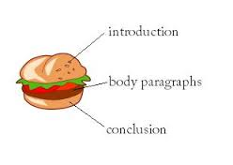
TEEL Paragraphs

T | topic sentence |  | Tells the reader what the paragraph will focus on. Try to keep away from putting examples in this sentence.
E | evidence | Supporting Sentences | Example from the text that support what point you are making in your topic sentence.
E | explanation |  | Explain what the examples SHOW the reader. What is REVEALED about the character in the text?
L | link back to the topic |  | I like to think of this as the ROUNDING OFF sentence. Sum up your main idea.

