Most people have a hobby.

It takes them away from their daily life and fills them with joy; they make an outcome of something they would love to achieve. One of my many hobbies is recording films. My name is Rhys and this is my story.

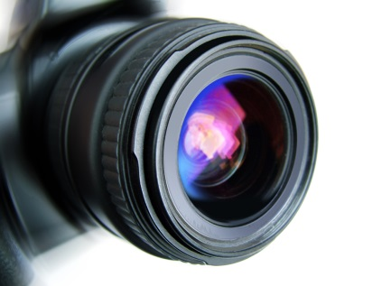D:\Users\RhysSh\AppData\Local\Microsoft\Windows\Temporary Internet Files\Content.IE5\7O9AANYZ\MC900361276[1].wmfWhen I first picked up a camera, I had no idea how to use it. But then eventually I started to aim it at certain objects and press a magical button, and then…’Poof!’ A light would flicker and the image I wanted to capture became a square photo on the digital screen. I remember many times where I would play paparazzi with trees and rocks: the most uninteresting of objects were becoming my models.

But the time where I really started to open my reach was when I entered Media classes in Year 10. I started to take my models more seriously, and for the first time in my life, I started to take pictures with meaning. One click after another, Snap! Snap! Snap!

By then, I found what I truly loved, capturing images was okay, but telling stories was a whole new level. This is about the time where I started to record and found a whole new side to being behind the camera.

I learnt new angles. If I moved the camera underneath where the models face was, I could make it seem bigger (Vice versa if I wanted to make it seem smaller). Doors began to open in my mind of the possible opportunities of this new tool.

It was incredible! I could press a button and move around as much as I liked; it could pick up sound, colour, light and darkness. I portrayed the rocks and oak for models with heartbeats. Animals, birds, people. Wait…people!

My first video I was in was of an action based film. A man gets his phone stolen off him and he goes to great lengths to get it back. It involved a lot of running, camera angles and editing, but the end result was fantastic. It inspired me to make even more films.

D:\Users\RhysSh\AppData\Local\Microsoft\Windows\Temporary Internet Files\Content.IE5\MDCEQIDL\MC900383698[1].wmfBut then there came a point where I asked myself, ‘I’ve come this far…what am I going to do next? What should I do next?’

I was taking my hobby on even more than I expected, but I’m glad it did, because technology is becoming our future. I have to follow with the times. I started looking at bigger, more trustworthy brands then a simple, cheap quality type.

The thing is, though, they cost a lot of money, so I had to make do with most resources that I already had. A simple camera stand, An SD card, a camera and its charger was all I needed.

There were many approaches I could take with a film. I could make it realistic based or a fictional story. But the types that really seem to ‘cut deep’ were the personal films. It can show a different to side people you know, or show you this person’s passion they fight for. It can change your views, your ways, your approach or merely just entertain you.

Recording is a very powerful tool. It can show us reality, imagination, information or perspective.

D:\Users\RhysSh\AppData\Local\Microsoft\Windows\Temporary Internet Files\Content.IE5\7O9AANYZ\MC900363232[1].wmfAnd that is why I love my hobby.

Rhys Sheffield