Name: _____________
Planning Main Ideas for Your Speech
Use this graphic organiser to plan your major areas to cover… Put the topic in the centre. Start with your own ideas, then use the internet to search for more.
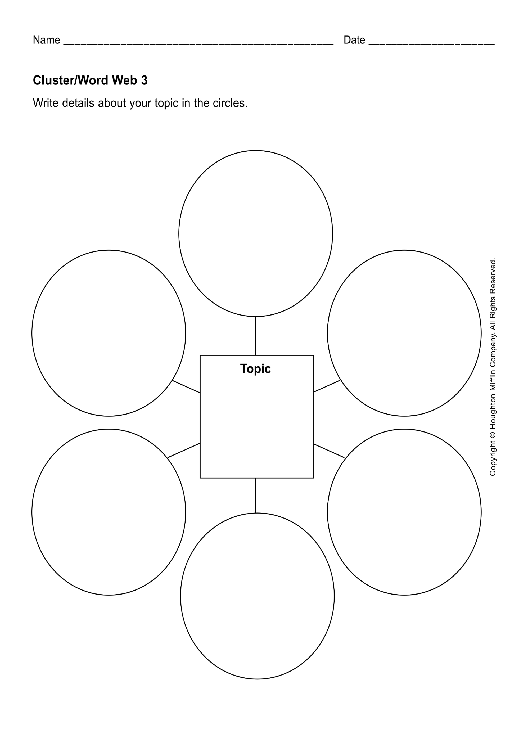
MAIN IDEA:

DETAILS:
MAIN IDEA:

DETAILS:
MAIN IDEA:

DETAILS:
MAIN IDEA:

DETAILS:
MAIN IDEA:

DETAILS:
MAIN IDEA:

DETAILS:

EXAMPLE

MAIN IDEA:

you can learn strategy

DETAILS:
MAIN IDEA:

it toughens you up to deal with challenges

DETAILS:
dealing with rough players
dealing with tough coaches
MAIN IDEA:
improves your fitness and health

DETAILS:
you do a lot of running
you do a lot of strength exercises
MAIN IDEA:

brings the family together

DETAILS:

MAIN IDEA:

it’s dramatic and exciting

DETAILS:

MAIN IDEA:

team spirit

DETAILS:

Why football is the best sport

