Analysing Text: repetition
NAME: ________________________________ DATE: ______________
Learning Intention: to be able to analyse writing techniques used by authors.
Success Criteria – using SOLO taxonomy
 | BEFORE TASK | AFTER TASK
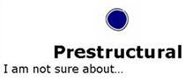 | I am not sure how to identify or explain repetition on my own. | I am not sure how to identify or explain repetition on my own.
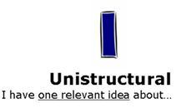 | I can independently identify examples of repetition. | I can independently identify examples of repetition.
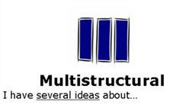 | I can identify and explain repetition. | I can identify and explain repetition.
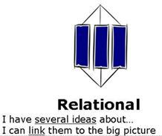 | I can identify repetition and explain the writer’s use of them. I have several ideas about why the author used this technique and/or the effect on the reader. | I can identify repetition and explain the writer’s use of them. I have several ideas about why the author used this technique and/or the effect on the reader.
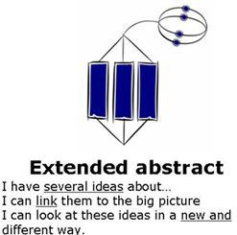 | I can identify repetition and explain the writer’s use of them. I have several ideas about why the author used this technique and/or the effect on the reader AND I can link the use of this technique to other texts I have read or viewed. I can explain how this technique might apply to other texts, such as advertising. | I can identify repetition and explain the writer’s use of them. I have several ideas about why the author used this technique and/or the effect on the reader AND I can link the use of this technique to other texts I have read or viewed. I can explain how this technique might apply to other texts, such as advertising.

taskRead the following extract In this description of his high school English teacher, journalist Russell Baker relies on repetition to convey an overwhelming impression of dullness and, well, primness. The passage appears in Baker's memoir, Growing Up (1982).

Mr. Fleagle
from Growing Up* by Russell Baker
When our class was assigned to Mr. Fleagle for third-year English I anticipated another grim year in that dreariest of subjects. Mr. Fleagle was notorious among City students for dullness and inability to inspire. He was said to be stuffy, dull, and hopelessly out of date. To me he looked to be sixty or seventy and prim to a fault. He wore primly severe eyeglasses, his wavy hair was primly cut and primly combed. He wore prim vested suits with neckties blocked primly against the collar buttons of his primly starched white shirts. He had a primly pointed jaw, a primly straight nose, and a prim manner of speaking that was so correct, so gentlemanly, that he seemed a comic antique.
task Identify the repetition and tricolon used in the passage about Mr Fleagle. Make annotations on the sheet first, then use the success criteria to write a TEEL paragraph about the writer’s use of the techniques. How far down the rubric can you get?
TRICOLON - A rhetorical term for a series of three parallel words, phrases, or clauses.

Examples of tricolon
- "I think we've all arrived at a very special place. Spiritually, ecumenically, grammatically." (Jack Sparrow, Pirates of the Caribbean)
- "The key to Springfield has always been Elm Street. The Greeks knew it. The Carthaginians knew it. Now you know it."(Herman, "Bart the General," The Simpsons)
- "Eye it, try it, buy it" (marketing slogan for Chevrolet in the 1940s)
- "Tell me and I forget. Teach me and I remember. Involve me and I learn." (attributed to Benjamin Franklin, among others)
- "You are talking to a man who has laughed in the face of death, sneered at doom, and chuckled at catastrophe." (The Wizard in The Wizard of Oz, 1939)
task Write your own description of a character. Consider drawing on someone you know and exaggerating – give them a fictional name. Choose a key feature (eg eyebrows, laugh, eyes, meanness, gentleness) or a key adjective (eg prim, dim, mean, crazy) and use that to create repetition.

