Analysing Text: hyperbole, sentence fragments & tricolon/repetition
Learning Intention: to be able to analyse writing techniques used by authors.
Success Criteria – using SOLO taxonomy
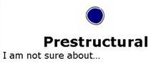 | I am not sure how to identify or explain hyperbole on my own. | I am not sure how to identify or explain sentence fragments on my own. | I am not sure how to identify or explain tricolons, or repetition on my own.
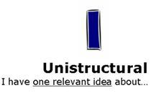 | I can independently identify examples of hyperbole. | I can independently identify examples of sentence fragments. | I can independently identify examples of tricolons, or repetition.
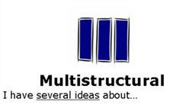 | I can identify and explain hyperbole. | I can identify and explain sentence fragments. | I can identify or explain tricolons or repetition.
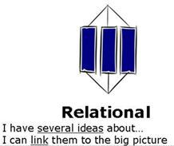 | I can identify hyperbole, sentence fragments and tricolons and explain the writer’s use of them. I have several ideas about why the author used these techniques and/or the effect on the reader.
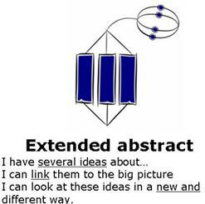 | I can identify hyperbole, sentence fragments and tricolons and explain the writer’s use of them. I have several ideas about why the author used these techniques and/or the effect on the reader AND I can link the use of these techniques to other texts I have read or viewed. I can explain how these techniques might apply to other texts, such as advertising.
taskRead the following extract by the narrator of Martin Amis's novel Money is John Self, a larger-than-life filmmaker whose gargantuan appetites are matched by the author's hyperbolic prose style. Note the effects created by tricolons and sentence fragments in these two paragraphs from the novel.

from Money* (1984)
by Martin Amis
In LA, you can’t do anything unless you drive. Now I can’t do anything unless I drink. And the drink-drive combination, it really isn’t possible out there. If you so much as loosen your seatbelt or drop you ashes or pick your nose, then it's an Alcatraz autopsy with the questions asked later.
So what can a poor boy do? You come out of the hotel, the Vraimont. Over boiling Watts the downtown sky line carries a smear of God’s green snot. You walk left, you walk right, you are a bank rat on a busy river. This restaurant serves no drink, this one serves no meat, this one serves no smiles. You can get your chimp shampooed, you can get your back tattooed, twenty-four hours, but can you get lunch? And should you see a sign on the far side of the street flashing BEEF--BOOZE--NO STRINGS, then you can forget it. The only way to get across the road is to be born there. All the signs say DON’T WALK, all of them, all the time. That is the message, the content of Los Angeles: don’t walk. Stay inside. Don’t walk. Drive. Don’t walk. Run! I tried the cabs. No use. The cabbies are all Saturnians who aren’t even sure whether this is a right planet or a left planet. The first thing you have to do, every trip, is teach them how to drive.
task Read the following definitions of tricolon, hyperbole and sentence fragments, then identify the techniques in the two paragraph passage by Martin Amis. Make annotations on the sheet first, then use the success criteria to write a paragraph about the writer’s use of the techniques. How far down the rubric can you get?
TRICOLON - A rhetorical term for a series of three parallel words, phrases, or clauses.

Examples of tricolon
- "I think we've all arrived at a very special place. Spiritually, ecumenically, grammatically." (Jack Sparrow, Pirates of the Caribbean)
- "The key to Springfield has always been Elm Street. The Greeks knew it. The Carthaginians knew it. Now you know it."(Herman, "Bart the General," The Simpsons)
- "Eye it, try it, buy it" (marketing slogan for Chevrolet in the 1940s)
- "Tell me and I forget. Teach me and I remember. Involve me and I learn." (attributed to Benjamin Franklin, among others)
- "You are talking to a man who has laughed in the face of death, sneered at doom, and chuckled at catastrophe." (The Wizard in The Wizard of Oz, 1939)
HYPERBOLE - A figure of speech (a form of irony) in which exaggeration is used for emphasis or effect; an extravagant statement. Adjective: hyperbolic. Contrast with understatement.

Examples of hyperbole
- "Ladies and gentlemen, I've been to Vietnam, Iraq, and Afghanistan, and I can say without hyperbole that this is a million times worse than all of them put together." (Kent Brockman, The Simpsons)
- Principal Skinner: The things you don't know would fill a whole library and leave room for a few pamphlets.
SENTENCE FRAGMENTS - A verbal bit or fragment used as an autonomous unit to create an effect of abruptness and rapid transition.

Example of Sentence Fragments
"New Year's Eve on Broadway. 1931. The poet's dream. The bootlegger's heaven. Lights. Love. Laughter. Tickets. Taxis. Tears. Bad booze putting bills into tills. Sadness. Gladness. Madness. New Year's Eve on Broadway." (Mark Hellinger, ""New Year's Eve on Broadway." Moon Over Broadway, 1931)

