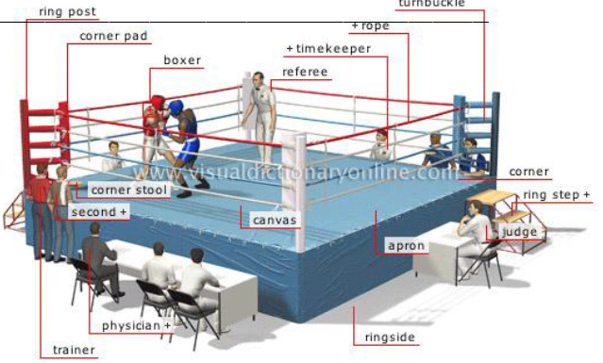
Name: _____________

Million Dollar Baby

Discussion Questions

Learning Intention: be able to think deeply about the messages and values that texts [Million Dollar Baby] get across [through analysing characters, film techniques, themes explored...]
- What is ironic about Eddie only having one eye?
He seems to see more than Frankie. It is ironic that he only has one eye.
- Was Frankie right to help Maggie end her life? Give your own answer here. Discuss. Consider the following:
  - Hint: what do you know about the story of Christopher Reeve and what comparisons can you draw between his story and Maggie’s?
  - What do you think Maggie’s quality of life was like after the accident?
  - Why do you think Maggie tried to commit suicide by biting her tongue?
  - How did this affect Frankie’s thoughts and decision on euthanasia?
- What is the purpose of the character of Danger? How did you feel about him? How did your reaction change throughout the film? Perhaps the film is reminding us that in reality, not everyone achieves their dream. Danger is also the comic relief amongst all the seriousness and darkness of the film. He provides some emotional contrast in the film. He also helps bring a positive tone to the end of the film.
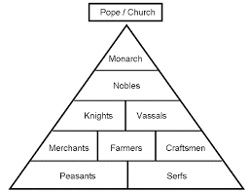
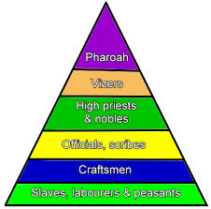
- How are lower class people represented by the film? Lower class include those living on or below the poverty line, such as unemployed or part time employed people. Hint: how does Maggie view her background? Hint: how are her family represented? Maggie and her family come from lower class, as does Danger. Maggie’s family are portrayed as ‘trailer trash’, living off the government. They are also portrayed as greedy, lazy, heartless. Maggie fights to get out of that lower social class. (AusVELS: Evaluate the social, moral and ethical positions represented in texts; Identify and analyse implicit or explicit values, beliefs and assumptions in texts and how these are influenced by purposes and likely audiences)
- What stood out about the relationship that developed between Frankie and Maggie? Consider:
  - How their relationship progressed and what it became. Give examples from the film
  - How their relationship compares to the other relationships in their lives.
- Blue Bear –
  - What sorts of things do we hear about Blue Bear before the fight?
  - Why mention that Blue Bear had once been a prostitute? What message is this sending to audiences? (AusVELS: Evaluate the social, moral and ethical positions represented in texts; Identify and analyse implicit or explicit values, beliefs and assumptions in texts and how these are influenced by purposes and likely audiences)
  - How is film technique used to build the tension and foreboding associated with Blue Bear? (AusVELS: analyse and explain how visual features of films may influence audience response.)
  - How did you respond emotionally towards Blue Bear when she cheated in her match with Maggie?
  - How did you feel towards Maggie when she responded by cheating? How were your reactions different? Why do you think that is?
- Why do you think Frankie felt responsible for Maggie’s injuries? How does he cope with blaming himself?
- What are your thoughts and feelings about how the film ends? Consider
  - Why do you think Frankie disappeared?
  - Should it have had a happier ending?
  - Endings are critical – they emphasise the ultimate meaning and message of a story – what is this film saying about life? about euthanasia? (AusVELS: Evaluate the social, moral and ethical positions represented in texts; Identify and analyse implicit or explicit values, beliefs and assumptions in texts and how these are influenced by purposes and likely audiences)
- One way of viewing the boxing element of the story is seeing it as a metaphor for ‘fighting’ or having a fighting spirit. How does the idea of a fighting spirit apply to various characters? Which characters show a fighting spirit, and how? What other texts deal with similar issues? (AusVELS: Make relevant thematic and intertextual connections with other texts.)
- Is this film an endorsement of the following?
  - Euthanasia
  - Female athletes in violent, typically male sports such as boxing
  - Not judging prostitutes by their profession
  - Blood is thicker than water - In modern society, the proverb "blood is thicker than water" is used to imply that family ties are always more important than the ties you make among friends.
  - Can you think of any other issues, types of people, etc that the movie endorses or doesn’t?
(AusVELS: Evaluate the social, moral and ethical positions represented in texts; Identify and analyse implicit or explicit values, beliefs and assumptions in texts and how these are influenced by purposes and likely audiences)

Analysing images

Learning Intention: be able to dig deeper into why images are presented in particular ways.
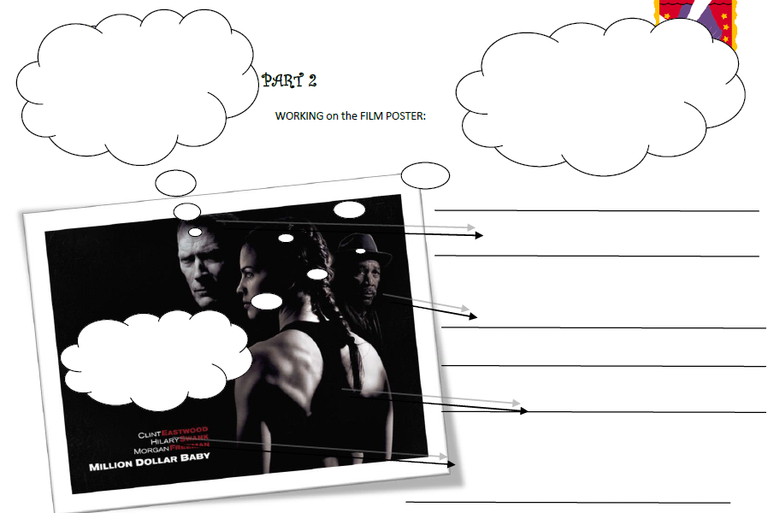
CHARACTER MAP
Learning Intention: to do a detailed analysis of characters using evidence to support your interpretation.

FRANKIE | MAGGIE
Context [time period and place]
This film is set in at a time when...

Background + Job
What does boxing mean to them?
To Frankie boxing is...  I know this because... | To Maggie boxing is...  I know this because...
What do they value most? What is most important to them?
Frankie values...  I know this because...  He also values...  I know this because... | Maggie values...  I know this because...  She also values...  I know this because...
This character fears...
Frankie fears...  I know this because... | Maggie fears...  I know this because...

Do they change? If so, how?
In the beginning Frankie was...  By the end he is...  This happened because... | In the beginning Maggie was...  By the end she is...  This happened because...
Choose 3 character traits for each character and support your choice with evidence from the text. Below are some words to consider, but don’t feel limited by them.
Cranky easy-going temperamental moody desperate flabbergasted anguished irritable
Strong-willed over-ambitious sophisticated natural intellectual spontaneous stubborn credulous
Frankie is...  I know this because... | Maggie is...  I know this because...
He is...  I know this because... | She is...  I know this because...
He is...  I know this because... | She is...  I know this because...

Viewing Million Dollar Baby from the perspective of the central relationship: one interpretation

Million Dollar Baby hits us with the grittiness of the boxing world. We begin the story in the ring with trainer, Frankie (Clint Eastwood), advising his star boxer to let his opponent hit him. It turns out to be the winning strategy. A woman, who although 31, comes across more as a girl, watches the match from the shadows. We soon discover that Maggie is from a family who live in poverty or prison and who have no ambition to do anything differently. Maggie has a determination that is exemplified in every scene she appears in. She wants Frankie to be her trainer. She sees something special in his abilities and will not take no for an answer. She is the antithesis of Frankie’s daughter who, for reasons unknown to the audience, returns every letter he sends her.

We soon piece together that Frankie’s harsh personality is at least in part his way of protecting himself from further hurt. He does not trust himself to care openly about others. Audiences can see that beneath this rough exterior he does in fact care a lot. “You’re not going to cry, are you?” he asks Maggie and then relents and lets her use his speed bag. He allows Danger to remain at the gym despite the fact that Danger doesn’t pay the fees and has no chance of learning to box.

Morgan Freeman’s character plays the part of the audience, who watches Frankie’s antics with amusement, wisdom and concern.

Maggie’s persistence, loyalty and honesty pays off. She wins Frankie’s heart.

In this film, boxing is a metaphor for a fighting spirit, and Maggie epitomises that fighting spirit. She won’t give up her dream to box and she won’t give up on getting Frankie to be her trainer. When she becomes paralysed she won’t let her body be taken from her, piece by piece, but is determined to die with her spirit intact.

The film leaves us with an unsubtle reminder that life does not promise us any happy endings, and does not promise to keep us free from pain and suffering. In spite of the darkness inherent in the film’s realism, we are left feeling that if only we can find a true relationship of love and affection that is displayed between Frankie and Maggie, that we might just have come through life’s tragedies with the most important parts of us intact: our heart and our spirit.

