Read the abridged review below and complete one of the activites that follows.

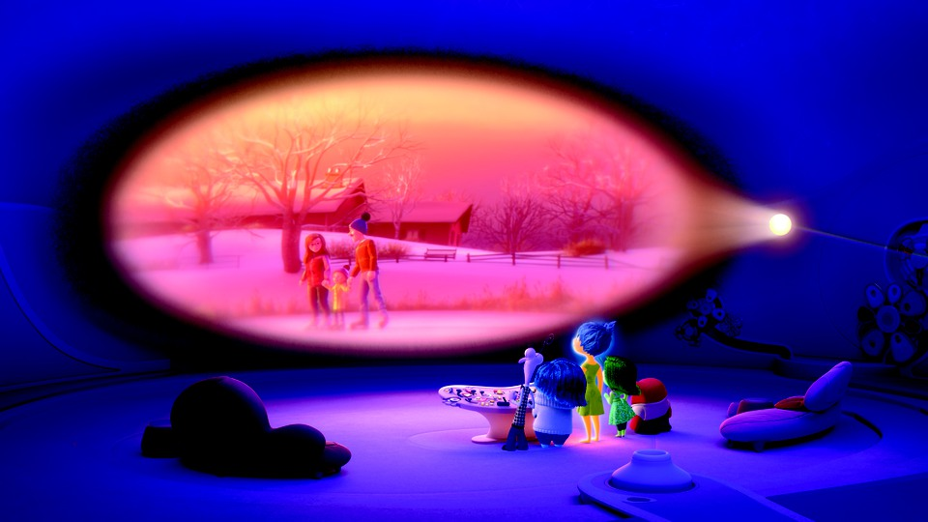

Inside Out will inspire tears of joy in parents and Pixar fans alike
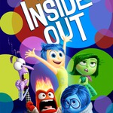
By A.A. Dowd@aadowd Jun 17, 2015 4:04 PM

Inside Out
Director: Pete Docter, Ronaldo Del Carmen
Runtime: 94 minutes
Rating: PG
Cast: Amy Poehler, Phyllis Smith, Kaitlyn Dias, Lewis Black, Mindy Kaling, Bill Hader, Richard Kind

Inside Out, the first new Pixar movie in two years, takes place almost entirely within the mind of a preteen girl, where five personified emotions struggle to guide her through a life crisis. Looked at one way, this is a very simple story of childhood growing pains: Forced to say goodbye to her friends and the happy life she’s built in small-town Minnesota, 11-year-old Riley (Kaitlyn Dias) is abruptly uprooted when her father lands a job in San Francisco. The mundane hardships that follow—a disastrous first day at the new school, a sports tryout gone wrong—don’t unfold from Riley’s perspective, exactly. Rather, they’re experienced through the eyes of her emotions, the anthropomorphized feelings that run the control booth in her mind. Joy, a yellow sprite is de facto leader of the group. But she has to share console space with the other color-coded voices in Riley’s head: eye-rolling Disgust, skittish Fear, literally hotheaded Anger, and glum Sadness.
Riley’s personality is represented through a series of themed islands, like Honesty, Family, and the all-important Hockey. Memories, the currency of her headspace, arrive in the form of glowing orbs, coloured by a particular shade of emotion. The meat of the movie is the buddy-comedy adventure embarked upon by Joy and Sadness.
This movie is chiefly concerned with the tough business of letting go. His most casually devastating creation is Bing Bong (Richard Kind), Riley’s nearly forgotten imaginary friend. Part elephant, part dolphin, all tragicomic figure, Bing Bong scavenges the dusty shelves of his creator’s memory bank. He’s the most poignant symbol of what the movie is really about: the gradual, almost imperceptible demise of childhood.
The film makes the point that it’s life’s seemingly insignificant moments that shape who we become. Another key message is that feeling melancholy is not just healthy, but entirely necessary. Sadness, in other words, is as important as happiness.

Select one of the topics below to write about. Because some of these topics can be quite personal, it’s up to you whether you let me read it.
- Write about memories of your childhood, such as memories of changes, things left behind, losses, experiences that shaped you. What are your core memories?
- Write about a memory that has a mixture of emotions. Be descriptive. Take us into the memory if you can.
- Both Tomorrow, When the War Began and Inside Out deal with issues of letting go of childhood. In Tomorrow, when the War Began, it’s a sudden change that’s forced on the group of teenagers. In Inside Out it’s more gradual. Ellie had to become emotionally tougher. 11-year-old Riley has to let all of her emotions be expressed. Who do you relate to more – Ellie needing to become tougher, or Riley, needing to let herself express all the sides of herself more? Explain your response.
- “a disastrous first day at the new school, a sports tryout gone wrong” – Write about your own disasters - or you could write about disasters your friends or family members have experienced – family stories are often full of disasters!
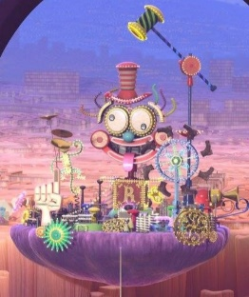

- “Riley’s personality is represented through a series of themed islands, like Honesty, Family, [Friendship], Goofball and the all-important Hockey.” – What are your ‘personality islands’? Select 4 to 8. Explain why you are like each one – this could include a memory or just a general explanation.
- In the film Riley has the memory of an imaginary friend, Bing-Bong. Think about the characters that stick out strongly from your childhood. Who are they are what do they represent, or what did you learn from them? For example, the Cookie Monster stands out strongly in my childhood memories. He represents greed but also the enjoyment of food. Barbie was a big character in my childhood too. She represented the desire to be attractive and dress nicely. She only drove sports cars and she wore elaborate ball gowns.

