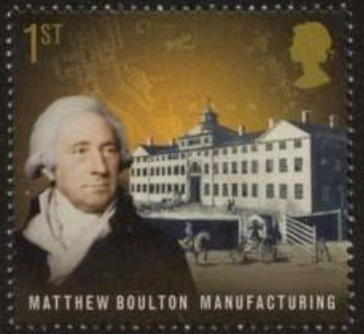
Dear
To: ________________________
_____________________________
_____________________________
_____________________________
_____________________________

WRITE A POSTCARD HOME FROM INDUSTRIAL BRITAIN IN THE EARLY 1800s
NAME: __________________________
Learning Intention: to demonstrate understanding of the effects of the Industrial Revolution on people’s living conditions.
Use all the materials we have seen so far, including those in the Walk Around activity, to send a postcard home from Britain during the Industrial Revolution: After spending a week in industrial Britain, you send a postcard home. Use your own words and those on the sheets to help you describe what life is like here.

FIRST, CREATE A WORD BANK OF AT LEAST 15 WORDS THAT COULD BE USED, INCLUDING DESCRIBING WORDS, PLACES, OBJECTS AND PEOPLE. Eg damp, Leeds, terrace houses, lavatory...

Write your postcard. Print off an image from online to put into the top box, or do this activity electronically. The document will be located in STUDENT PUBLIC – RESOURCES – MISS SKY – HUMANITIES.
You can change the stamp too, if you wish.

