Deadly, Unna

1. Brainstorm a list of all the characters you remember from the novel. Underline the main characters. Select 5 main characters and write a detailed paragraph about each one – one slide for each character. Go as deeply into who the character is as possible. Use the following to guide your thoughts and analysis:
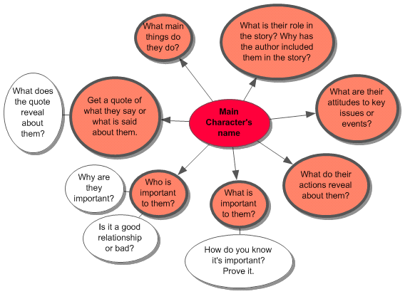
2. What are the various meanings of the title of the book, Deadly, Unna? Describe at least two ways in which you think it is appropriate to this story. Then come up with 3 alternative titles that capture an essence or key message of the book.

