85 per cent support voluntary euthanasia - poll
- AAP
- OCTOBER 26, 2009 5:51PM
SUPPORT for voluntary euthanasia is on the increase in Australia, with a new survey showing 85 per cent of the country is in favour of it.
The result from the poll, conducted by Newspoll on behalf of Dying with Dignity NSW, saw a five point increase in support from the results of the last survey, conducted in 2007.
The 2009 study, involving 1201 adult respondents, found 10 per cent of Australians opposed voluntary euthanasia while five per cent were unsure.
Support was at its greatest in Western Australia where 88 per cent of respondents were in favour of voluntary euthanasia, while 87 per cent of South Australians were in favour of it, with six per cent opposed.
New South Wales residents were 87 per cent in favour, an increase of 12 points on the last survey, while Victoria had 84 per cent support and Queensland 82 per cent.
Dying with Dignity NSW spokesman Robert Marr said the results showed Australians wanted to explore the issue.
"With such massive support across the country, the results of this poll send a message to the country's lawmakers that the time has come for a full debate on this issue," Dr Marr said.
The poll also found no real difference in support between men and women when it came to voluntary euthanasia. Eighty-six per cent of women were in favour of it, compared with 84 per cent of men.
http://www.sunshinecoastdaily.com.au/news/euthanasia-call-in-focus/2447408/

Dying with Dignity: Euthanasia bill in Senate today
Roxanne Mccarty-O' Kane | 10th Nov 2014 6:34 AM
70 COMMENTS
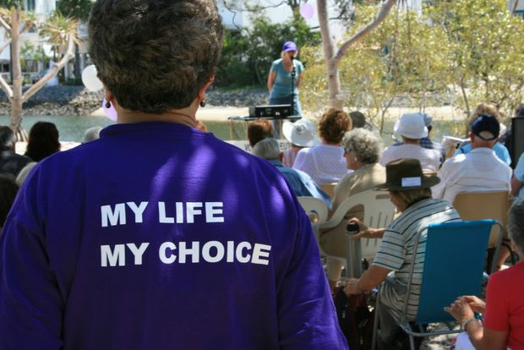
The Dying with Dignity Bill will be voted in the senate today.Bobbi Moore/BM 169226x2

VOLUNTARY euthanasia advocates are not confident the Senate will pass the proposed Dying with Dignity Bill today, but are grateful it has sparked a national debate.
The Federal Government referred the Medical Service (Dying with Dignity) Bill 2014 to the Senate Legal and Constitutional Affairs Legislation Committee for inquiry in June this year.
The Bill outlines the rights of terminally ill people to seek assistance to end their lives within set frameworks and safeguards.
More than 600 submissions were received by the committee before they closed on August 21.
The volume of feedback was so great, the committee sought an extension of its original October 22 deadline.
Buderim-based voluntary euthanasia activist Marshall Perron said while it was great to see the Bill on the agenda, he was not confident it would be adopted.
Mr Perron was instrumental in the passage of the world's first Voluntary Euthanasia law in the Northern Territory Legislative Assembly in July, 1996.
Four people were able to take their lives under the Rights of the Terminally Ill Act before it was overturned by the Federal Government nine months later.
"The history of the federal parliament on this subject is not good," he said.
"There is a very powerful Catholic clique from the Prime Minister down and I believe that they will make it very difficult for those politicians who do want to progress this issue.
"They claim it is against their religion, but what about those of us who aren't religious? To them I say, 'You can die any way you want and I would support you in how you choose to live your life, just don't interfere in what I want for my death'."
Mr Perron said while some states had come very close to passing legislation supporting voluntary euthanasia on the back of a private member's bill, Queensland had so far been the only state where it had never been introduced to parliament.
Dying with Dignity Queensland president Jos Hall said she knew many of the hundreds of submissions to the senate committee had been handwritten by people who had witnessed first-hand the terrible suffering endured by their loved ones as they lived with terminal illness.
"As an organisation, Dying with Dignity is very distinctly focused on the idea of bringing about legislative solutions for people who want medical assistance to relieve suffering," Ms Hall said. "It's about giving people the choice in what one-in-five of us will face at some point in our lives."
Ms Hall said recent polls showed 80% of Australians supported voluntary euthanasia and it was time the politicians "get on board".
The Australian College of Nursing welcomed the Bill but cautioned that greater consideration needed to be given to the role of nurses in end-of-life care and the context and settings in which dying with dignity services were provided.
Member for Fisher Mal Brough said although he had not seen the Bill, he supported the "notion of dying with dignity".
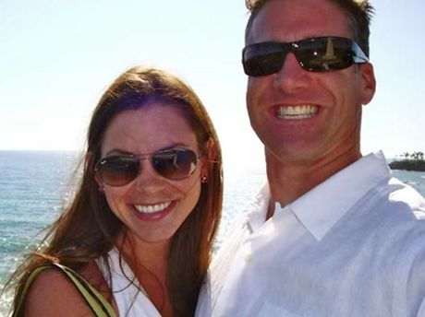
Anyone bereaved by suicide and in need of support can call StandBy on 5409 4995 or 0407 766 961. If you are in crisis, contact the Suicide Call Back Service on 13000 659 467 or Lifeline on 13 1114.Brittany pictured with her husband Dan
DISEASE DIDN'T TAKE BRITTANY'S DIGNITY
THE name Brittany Maynard has become synonymous with the Dying with Dignity movement.
The American 29-year-old ended her life on November 1, surrounded by family, after launching a campaign to promote laws that allowed people with terminal illnesses to choose the time of their deaths.
Brittany was diagnosed with a stage-four malignant brain tumour in April and given six months to live.
RELATED: Brittany Maynard ends her own life
After speaking with a number of medical experts, who outlined how she could lose her ability to speak and use her own body before she died, Brittany prepared a bucket list and set about ticking the items off.
In an interview with People Magazine, Brittany said "My glioblastoma is going to kill me, and that's out of my control.
"I've discussed with many experts how I would die from it, and it's a terrible, terrible way to die. Being able to choose to go with dignity is less terrifying."
On her Facebook page, Brittany wrote "Goodbye to all my dear friends and family that I love. Today is the day I have chosen to pass away with dignity in the face of my terminal illness, this terrible brain cancer that has taken so much from me … but would have taken so much more."
Dying with Dignity Queensland secretary Julian Pennisi corr said Brittany's openness and personal account of why she chose to end her life had been a motivator for many people to think about their own mortality and what they would do if they were faced with a similar situation.

READER POLL

Do you support Dying with Dignity?

Moral dilemmas – Euthanasia
Moral dilemmas are situations when you have to choose between two choices that both have negative consequences.
- Write a summary of the article that captures the most important ideas. You can do it as a paragraph or mindmap.
- Do you consider this article to be balanced or biased? What makes you think this? Consider which sides are represented (pro/con) and whether they’re represented in a balanced way.
- What images have been chosen to accompany this article? Describe them, then state whether they have a persuasive element. Explain the persuasive element.
- Identify the following persuasive techniques:
  - Expert evidence
  - Anecdote
  - Statistic
  - Appeal to self-interest/fear of what could happen to you in the future
  - Inclusive language

OPINION

Activist dead wrong on voluntary euthanasia
Chrys Stevenson and David LeafABC RELIGION AND ETHICS18 OCT 2011
HOWEVER WELL-INTENTIONED SELF-APPOINTED ANTI-EUTHANASIA ACTIVISTS MAY BE, NO-ONE IS SERVED WHEN PATENTLY FALSE INFORMATION, INTERNET RUMOURS AND COMMON GOSSIP ARE PUBLICLY DISSEMINATED AS FACT.CREDIT: POSTMAN76 (WWW.FLICKR.COM)
On a recent episode of ABC's Q & A, disability rights activist John Moxon painted a frightening picture of societies in which voluntary euthanasia (VE) is legal.
Speaking from the audience, Moxon, a quadriplegic, warns that the VE legislation currently before the South Australian parliament "will enable a doctor to kill somebody, on the judgement of the doctor alone, that the person's life is not worth living."
After the show, Moxon's anti-euthanasia group ProLivingposted the following comment on their website:
"ProLiving supporter John Moxon gave a good account of a disability perspective on the issue of euthanasia in the ABC program Q & A on 19 September."
This is alarming. If the "disability perspective" on VE is based on the kind of information disseminated by Moxon on Q & A, people with disabilities are being grossly misinformed.
While we share some of ProLiving's reservations about the adequacy of the South Australian VE bill, the concerns expressed by Moxon are demonstrably unfounded. Surely the rights of the disabled include the right to accurate and well researched information, not propaganda based on horror stories, urban myths, rumour, conjecture, fear-mongering and dogmatic moralising.
We will begin by deconstructing John Moxon's Q & A comments from the perspectives of a trained researcher and full-time carer, and a practicing physician with extensive emergency, intensive care and palliative care experience.
In the course of his discussion with the panel, Moxon confided that, prior to his accident, he expressed a strong desire to die rather than live with a serious physical disability. He implied that, if VE was legal at the time of his accident, this misguided conviction might have deprived him of the happy and productive life he has enjoyed for the last forty years.
This fear is understandable but unfounded. Doctors are not compelled to obey a patient's every wish - especially where those wishes conflict with a positive prognosis. We are aware of no jurisdiction in which a VE request made "in case" of injury would be given any weight whatsoever by a treating medical team. Even if Moxon decided after his accident that death would be preferable, he would be unlikely to satisfy the criteria for VE in any jurisdiction.
In Oregon, as with the proposed South Australian bill, a patient is not eligible for VE unless their condition is terminal. In places where serious physical disability is eligible, it is highly unlikely a spinal patient in the early stages of treatment would meet the criteria for VE. Any legislation which includes the safeguards routinely implemented in other jurisdictions, places spinal patients at no risk of premature euthanasia - either with, or without, their permission.
But suppose, argues Moxon, VE is legalised and his quadriplegia is compounded by a stroke. What if some pro-euthanasia doctor arbitrarily decides he would be better off dead? Again, this fear is completely unwarranted.
In no jurisdiction is a doctor permitted to euthanize a stable patient. Unless she is prepared to be tried for murder, a doctor cannot arbitrarily and independently decide to end someone's life based on her own value judgement.
It is true that a terminal patient in unremitting pain may be offered drugs that might, incidentally, hasten their death; but Moxon insists he has no problem with that. In such cases, the patient (if possible) and his family (if appropriate) would be consulted and the decision made by a highly trained medical team working in accordance with strict ethical protocols.
Asked whether people should have the right to say for themselves if they should be euthanized, Moxon replied: "Do I think a 15 year old lad ... should be euthanized because he's depressed and feels he needs to commit suicide? Or someone 25 or 35 with no obvious disability other than their depression? My answer is, 'No'."
Well, we'd say "no" as well! Let us make it plain. In no circumstances and in no jurisdiction anywhere in the world, can a depressed 15 year old wander into a doctor's office, ask to be put out of his misery, and have the doctor legally comply.
In the Netherlands, some severe psychiatric conditions have been deemed eligible but there is simply no way a 15 (or 25-30) year old with a temporary depression would meet the criteria.
In Oregon, as with the South Australian VE legislation, a patient must be terminally ill before being considered for VE. A depressed 15 year old would not meet the criteria. Further, under the South Australian proposal, a 15 year old would not meet the minimum age limit, even if he were terminally ill.
It is true the Dutch have lowered the VE age limit to 12, but it is approved only if the child's condition is extremely severe and even then, barring extreme and unusual circumstances, parental consent is required.
But, Moxon insisted, such things do happen and he offered a "real life" example as evidence. He tells us about an incident in America, where a 25 year old ballet dancer with arthritic toes was so devastated at being unable to dance she asked her doctor to euthanize her. "And the doctor said, 'Well I didn't really want to do it, but she was asking me to' ..."
"Now, to me, you know," says Moxon, "that is a symptom of what I would call a sick society." We agree - if that is what happened. But it almost certainly didn't - and certainly not as described.
The widespread dissemination of this particular urban legend dates back to a 1995 anti-euthanasia video, Euthanasia: False Light. In the video, Robin Bernhoft MD, an environmental health specialist from California, says:
"One of the people that does euthanasia over there [in the Netherlands, not America], a couple of years ago, euthanized a 26 year old ballerina, because she had arthritis in her toes and she didn't want to live any more. His comment was, 'One doesn't enjoy this sort of thing, but it's her choice'. You're disposed of because you're 26 and you can't dance anymore? ... We could take it at face value because she's got a short term depression and you kill her."
Again, we have to repeat that under no jurisdiction in which VE is allowed would this scenario be legal. In the highly unlikely event it did happen as described, the doctor would be liable for murder.
In John Moxon's defence, it's not surprising he took this story on trust. When a physician like Dr Bernhoft publicly propagates this kind of unsubstantiated hearsay, it gives it an imprimatur of credibility which is hard to shake. But when one hears these kinds of stories, it is important to ask, "Who is this person and what is their interest in this subject? Is there a hidden agenda at work here?"
As it turns out, Bernhoft is not just a doctor; he is a fundamentalist Christian, a Catholic educational apostolate (religious leader), an apologist for creationism, co-host of a syndicated weekly Catholic radio show and a televangelist.
Dr Bernhoft is also something of a medical and scientific maverick, eschewing the scientific consensus on issues as diverse as evolution, autism and homosexuality. Even when the overwhelming weight of scientific evidence conflicts with his firmly held religious or personal views, Bernhoft tends to remain obdurate.
We don't believe Dr Bernhoft maliciously concocted the ballerina story. We do suspect, however, that this unsubstantiated scuttlebutt fits so neatly with his religious views on VE he never thought to question it. It is a testament to the poor level of knowledge about VE that, 16 years later, this story is still being used to mislead and alarm people - although not one skerrick of evidence exists to support its veracity.
In an interview on Sky News on 20 March 2011, Prime Minister Julia Gillard said, "I am not satisfied that euthanasia legislation can be enacted to make it safe and workable." Responding to Moxon's concerns, Q & A panellist Kristina Keneally echoes the Prime Minister's words. The former NSW premier explains that VE
"is an incredibly difficult thing to codify. It is an incredibly difficult thing for a government to put rules around. I haven't yet seen a government that's 'cracked it' as to how you would actually legislate or quantify for it."
That may be true if Australia was drafting the very first VE legislation. But, VE is already legal in four countries and three American states. The combined experience in managing, researching and building appropriate safeguards for VE legislation now totals over 80 years. It is of grave concern that our nation's leaders are so poorly informed about the existence and success of VE in so many jurisdictions around the world.
Despite the myths and propaganda spread by those who oppose it, VE legislation is working without undue risk to vulnerable groups. For example, a 2007 peer-reviewed study into VE found that:
"Rates of assisted dying in Oregon and in the Netherlands showed no evidence of heightened risk for the elderly, women, the uninsured ... people with low educational status, the poor, the physically disabled or chronically ill, minors, people with psychiatric illnesses including depression, or racial or ethnic minorities, compared with background populations. The only group with a heightened risk was people with AIDS."
Similarly unsubstantiated are claims that palliative care declines when VE is legalised. Palliative care in the Netherlands was poor when VE was introduced, but the Dutch government have since injected millions of Euros to improve the system.
By 2008, the Netherlands' palliative care system was ranked the fourth most effective out of 27 European nations. A 2010 world-wide ranking places the Netherlands seventh in the world. In Belgium, where VE has been legal since 2002, the same study ranked its palliative care system fifth in the world. And, in Oregon in 2009, over 90% of those who chose an assisted death were already housed in high quality hospice care.
There is simply no truth to the allegation that VE replaces high quality palliative care. If Australia follows the trend in other jurisdictions, our palliative care system (currently ranked second in the world) will only expand and improve if VE is legalised.
Reviews by government authorities and independent academics show that VE laws are working safely and effectively, but still the objections keep coming.
"If even one person's life might be wrongly cut short, VE should not be legalised," is a noble and oft-repeated sentiment. But we don't apply such a stringent test to any other area of public life - not to hospitals, pharmaceuticals, backyard pools, driving, boating, horse racing, car racing, drinking, smoking, cycling, surfing or a thousand other activities which routinely result in the loss of innocent lives.
Instead of using prohibition, we legislate to minimise risks, improve training and standards, refine the law where appropriate and prosecute those who break it. No legislation is perfect or risk free. Why is there a different standard for VE?
We are painfully aware that all the arguments, evidence and statistics in the world will not sway many of the opponents of VE. Their strategy, often successful, is to drown out the voices of reason with a veritable deluge of frightening (but fallacious) "facts."
But, ultimately, their objections can be reduced to a single, dogmatic (usually religious) conviction that VE should not be allowed under any circumstances - regardless of what safeguards are implemented. If every argument could be answered, every fear put to rest and every urban legend proved unfounded, they would still be opposed. This is their right, but it is not a basis upon which politicians should make public policy.
Legalised VE has passed the test of time. It is not perfect, but no area of human endeavour is. Advocacy groups like ProLiving certainly have an important role to play in protecting the interests of minorities and keeping them well-informed.
But, however well-intentioned self-appointed activists like John Moxon may be, no-one is served when patently false information, internet rumours and common gossip are publicly disseminated as fact.
Chrys Stevenson is a freelance writer, blogger and historian and a full-time carer. Dr David Leaf is a primary care physician with extensive formal emergency, intensive care and general practice training and experience. Dr Leaf serves on the board of Dying with Dignity NSW.

"Let people pass away in their own time" widower says
Madeline McDonald | 3rd Jan 2015 6:00 AM
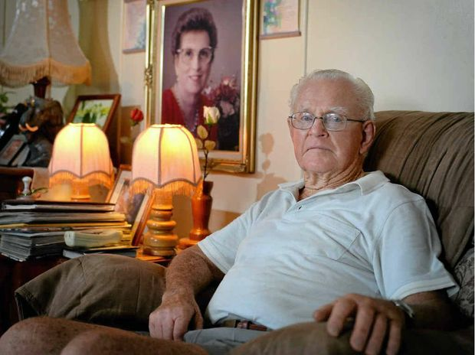
Vic Sneyd wrote a letter to the editor on his view on euthanasia. Photo Allan Reinikka / The Morning BulletinAllan Reinikka

ROCKHAMPTON'S Vic Sneyd sat by his dying wife's side every day until she took her last breath.
He wanted her to be surrounded by love and family in her final few weeks and to leave this Earth in her own time.
For Vic, as hard as it was to see his wife of 39 years become more and more frail, he couldn't believe that there were countries in the world where ending another person's life, euthanasia, was legal.
Vic this week wrote an emotional letter where he said euthanasia was a form of murder and was no way to end a person's life.
"What right does someone have to end somebody else's life? I don't believe anybody has the right to do that," he said.
"To end a person's life is called killing whether it is by stabbing, choking or giving a dose of poison as a medicine. This is called murder.
"Every person has the right to live their full life given to them whether short or long and I don't want my country legalising euthanasia.
"I witnessed the passing of my darling wife being by her side all of the time during her last week. Let people pass away in their own time. Don't end their life. There's just no need for it."
Vic's wife, Phyllis, was diagnosed with cancer of the liver in 1992 at the age of 60 and after 12 months of chemotherapy and treatment, the cancer returned to the centre of her liver and eventually took her life in 1995.
In her final days, Vic never left her side and tried to ease her discomfort by reliving the fond memories they had made together over the years.
Vic said people shouldn't talk about the pain their loved one might be in at that time and instead share enjoyable memories and help them take their mind off their condition.
"Not once did I ask her if she was in pain," he said.
"We never spoke of what pain she had because I believe that only adds to a patient's discomfort.
"Why ask them if they are suffering? Ease the pain by not talking about it and letting them enjoy the life they have left.
"Most of the time it's the people around their loved one who can't bear to see them nearing the end.
"But that doesn't mean you should end their life with a dose of poison."

- What point of view is this article supporting?
- Write a 4-6 sentence summary expressing Vic’s point of view.
- What persuasive technique is the most prominent in this article?
- Why might it be effective?
- Did you find it effective or not?

Euthanasia: the debate must start now
April 30, 2014 The Age
Editorial
Nine years ago, 58-year-old Steve Guest was dying from oesophageal cancer, and in intolerable physical and psychological pain. In July 2005, he took his own life with an overdose of a barbiturate used by veterinarians to kill animals. What has not been known until this week is that Mr Guest was supplied with this lethal drug by Dr Rodney Syme, a Melbourne urologist and campaigner for voluntary euthanasia, who had visited the terminally-ill man at his Point Lonsdale home in the weeks before his death. We know this because Dr Syme himself told The Age on Monday that he had done so.
Dr Syme, the vice-president of Dying with Dignity Victoria, said he had not chosen to speak out until now because he had not wanted to face the stress of a possible trial or conviction. Inciting, aiding or abetting a suicide is a criminal offence in Victoria and carries a maximum penalty of five years' jail. As we reported yesterday, Victoria Police has reopened the investigation into Mr Guest's death.
Dr Syme changed his mind, he told The Age's health editor Julia Medew, because he believes that creating a court challenge could set a useful legal precedent and accelerate the public debate on euthanasia. ''I just believe passionately that there are too many people suffering too much not to try a little bit harder to change things,'' Dr Syme said.
He draws a useful parallel with abortion reform in Victoria - another example of a once illegal practice that was partially decriminalised in a court case in which a judge ruled it to be reasonable. This effectively brought an end to a climate of secrecy and corruption similarly echoed by the present black market in this country for the drug Mr Guest took.
Certainly, as Dr Syme well knows, there has been woefully little progress in public discussion on all aspects of rational and assisted suicide. In fact, in political terms, the matter has sunk into inertia. Over the past 20 years, state Parliament has rejected 16 euthanasia bills, and Victorian Attorney-General Robert Clark said this week the government would not explore such legislation; nor would it refer the matter to the Victorian Law Reform Commission. This has provoked Dr Syme into taking such risky action. He is a courageous man.
The Age is committed to the encouragement of community debate on euthanasia because we believe it is only through such full and informed means can there be wider understanding and acceptance. However, we remain concerned that changing the laws on voluntary euthanasia and assisted suicide could result in possible ambiguities or abuses: euthanasia, as we have said, should not be permitted to become a subtle form of murder. Care and consideration are therefore essential.
What is clear, though, is that the public mood on rational and assisted suicide has changed, and has become more accepting. Part of this could be ascribed to specific examples. A year ago, The Age reported the remarkable story of 83-year-old Brighton woman Beverley Broadbent, who, before ending her own life, told us that she was ready to die. More recently, we reported on how 78-year-old advanced-dementia sufferer Sue De Ravin, who, despite writing a ''living will'' that would prevent her being resuscitated, is legally prevented from her death being hastened in any way.
The Victorian Law Reform Commission is, in fact, the ideal forum for community debate on euthanasia. Such a group of independent experts are ideally placed to receive submissions and report back in detail. The Napthine government should quickly overcome its reservations to refer the matter to the commission. Society expects nothing less.

Euthanasia: Lethal dose has fearful consequences
October 15, 2014 Anthony Fisher
The ailing should not be given the right to die, but rather the right to die well, writes Most Reverend Anthony Fisher.
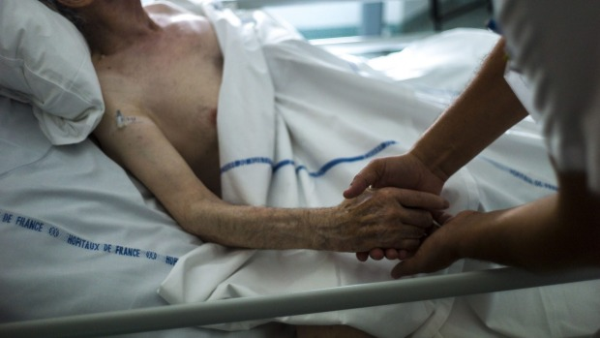
Euthanasia is not just a private matter, because it draws medical professionals, regulators and the whole community to the bedside. Photo: AFP
On Wednesday, a Senate committee will hear evidence on a euthanasia bill that would allow some people to be given a lethal injection on compassionate grounds.
I understand why some people want this. It's often because someone they've known and loved has had a "hard dying". Or because they are exhausted from caring for someone who is dying very slowly. Or because they are afraid of their own decline.
I sympathise with these reasons. I know that those who support euthanasia are not all grizzly Dr Deaths. This challenges me to think about what "a good death" means and how our community responds to the elderly, frail, disabled and dying.
But, however well-meaning, I don't think giving people a lethal dose is the answer.
Reason and experience show that euthanasia can't be made safe, because no law can prevent abuse in this area. In places like Holland and Belgium the numbers being medically killed are escalating and the range of cases keeps expanding beyond the "last resorts" for which it was first sold to the public.
Now people who aren't terminally ill, aren't even physically ill, people who haven't volunteered or can't volunteer, can legally be killed in those places and some want to extend it further – for example, to long-term prisoners and children.
Attempts to limit euthanasia by legalising and then regulating it have failed everywhere it's been tried. You can't prevent the subtle or overt pressure to request euthanasia. You can't stop people feeling or being made to feel they are a burden. You can't stop bean counters and over-stressed hospitals thinking some people should just hurry up and die.
Euthanasia is not just a private matter, because it draws medical professionals, regulators and the whole community to the bedside. It makes us all complicit. It asks us all to agree that some people are better off dead and that our laws and health professionals should make them dead.
Once we've accepted that some old people can be killed, why not some others? Why should it be restricted to the very sick? What about younger people who want it or those who aren't terminally ill? People who are just sick of life? People who are unconscious or too young or disabled to consent? It's not that I'm a nervous "slippery-sloper", it's just a matter of following the logic of the argument for giving some people a lethal dose.
Having undermined the principles that doctors never kill patients and that our state will not sanction killing, we will have changed what doctors are and what our justice system is. We will have changed how we relate to the "unwanted" people.
"Of course he'd say that, he's a bishop." But it's not just Christian leaders who worry about these things. Many believers, many secular thinkers, share in common the idea that you should never kill innocent people. Human dignity, human rights, human "unkillability", can't be lost or volunteered away. They don't depend on how healthy, useful or wanted you are.
Palliative Care Australia says that were all Australians given access to good palliative care they would be able not only to live well in their illness, but to die well too. My pastoral experience concurs: instead of signalling to people that their life is not worth living, we can and should ease their sense of meaningless in suffering. Sadly, many people lack such care at the end. Compassion demands that we offer everyone such real care, even when it's hard, rather than a lethal injection.
Euthanasia cannot be made safe. It makes vulnerable people more vulnerable and suffering people suffer more. Surely we can do better in Australia than inviting them to "volunteer" for early death.
Most Reverend Anthony Fisher is Catholic Archbishop-Elect of Sydney

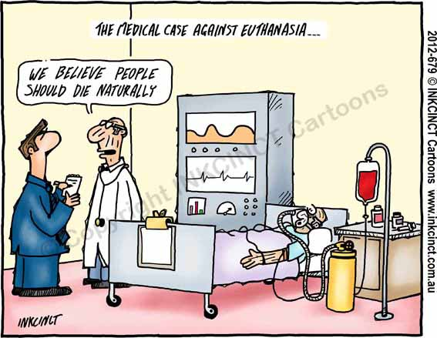

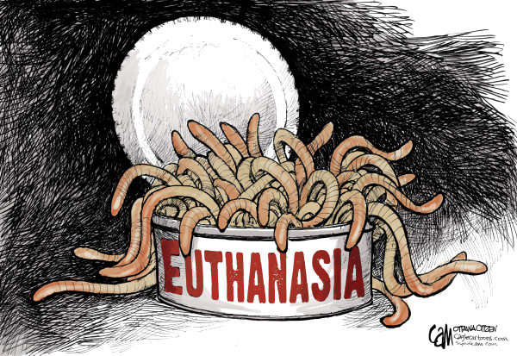
https://prezi.com/oonczgl5sl5p/ariels-moral-dilemma/ pros and cons of euthanasia
https://prezi.com/flprlkayyomw/moral-dilemma-euthanasia/ a discursive and informative presentation on euthanasia
https://prezi.com/mk1wm0drdn50/euthanasia/ UK based presentation with anecdotes on timeline

