NAME: ________________________________ Political Parties of Australia
TITLE OF PARTY | FORMED IN | FORMED BY | SPECIAL FEATURES | MAIN AIMS:
The Liberal Party of Australia  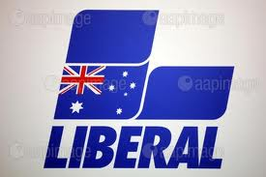 | - 1944 | - Robert MENZIES |  | - growth of Aust businesses  - raise living standards of all citizens  - promote family  - cut back gov spending  - cut back gov interference in society
National Party of Australia
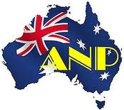
Australian Labor Party
Australian Democrats |  |  | - held balance of power in Senate many times
Australian Greens |  |  | - currently hold the balance of power
GLUE THIS SHEET INTO YOUR EXERCISE BOOK!!!

