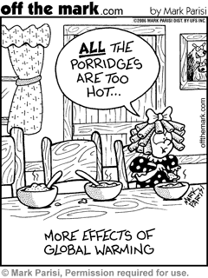

**NAME: _______________________**

**GLOBAL WARMING... EFFECTS**

**1**

|  |
| --- |
| **CARTOON 1** Why are all the porridges too hot? |
|  |
|  |
|  |
| **CARTOON 2** This cartoon is commenting on one of the  **effects** of climate change. What effect is it? |
|  |
|  |
| **CARTOON 3** According to this cartoon, what will  happen to the earth as a result of global warming? |
|  |
|  |
| **CARTOON 4**  What **effect** of climate change is this commenting on? |
|  |
|  |
|  |
|  |
|  |
|  |
|  |
|  |
|  |

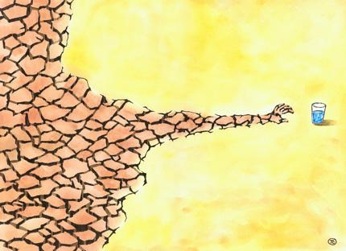

**2**

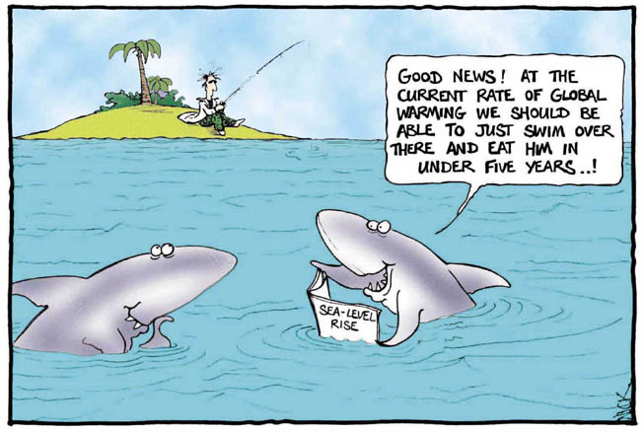

**4**

**3**

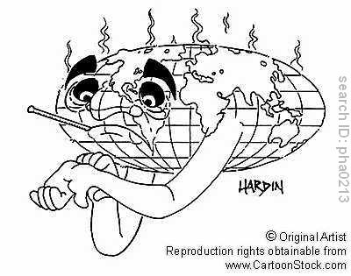

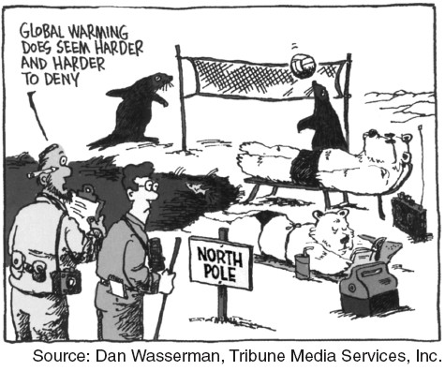

**5**

|  |
| --- |
| **CARTOONS 5 & 6** What geographic location have these cartoons decided to focus on? How is this  location linked to climate change? |
|  |
|  |
| Re-read the man’s dialogue in Cartoon 5. What does  it suggest about the human reaction to climate change? |
|  |
|  |

**6**

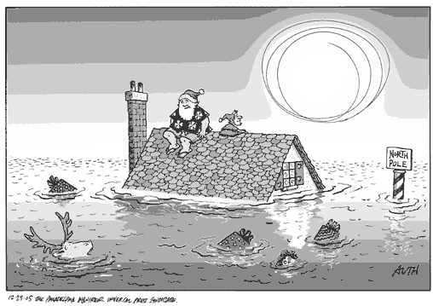

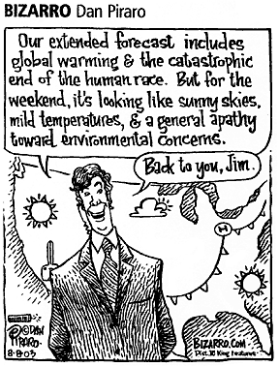

**GLOBAL WARMING... HUMAN REACTIONS**

**7**

|  |
| --- |
| **\* apathy = lack of interest** |
| **CARTOONs 7 & 8** show two different human  reactions to climate change. What reaction is |
| Cartoon 7 showing?  Cartoo |
|  |
|  |
|  |
|  |
|  |
|  |
| What reaction is Cartoon 8 showing? |
|  |
|  |
|  |
|  |
|  |
|  |
|  |
|  |
|  |
|  |
|  |
|  |
|  |
|  |
|  |

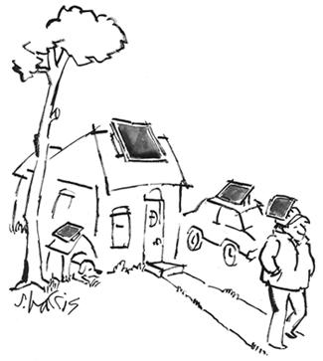

**8**

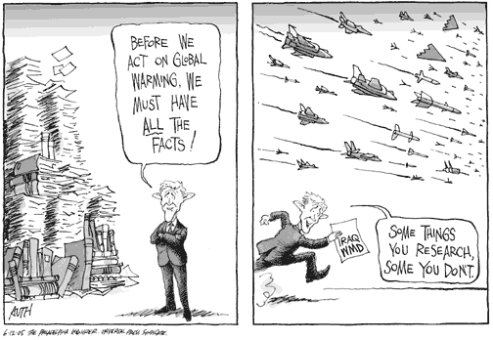

|  |
| --- |
|  |
|  |
|  |
|  |
|  |
|  |
|  |
|  |
|  |
|  |
|  |
|  |
|  |
|  |
|  |
| **CARTOON 10** How does the |
| cartoonist immediately convey  that the cartoon is about the USA  government? |
|  |
|  |
|  |
|  |
| What is the central message of  this cartoon? |
|  |
|  |
|  |
|  |

**CARTOON 9** Why might the US government have acted on Iraq’s so-called weapons of mass destruction so much faster than acting on global warming?

**9**

**GLOBAL WARMING... GOVERNMENT REACTIONS**

**10**

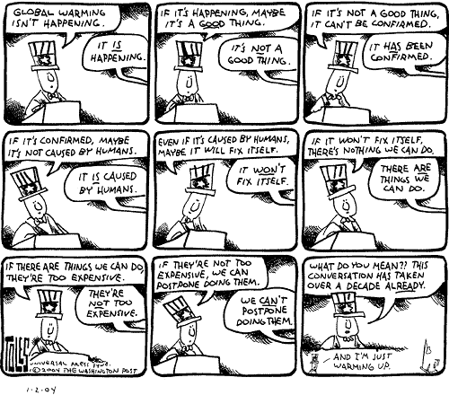

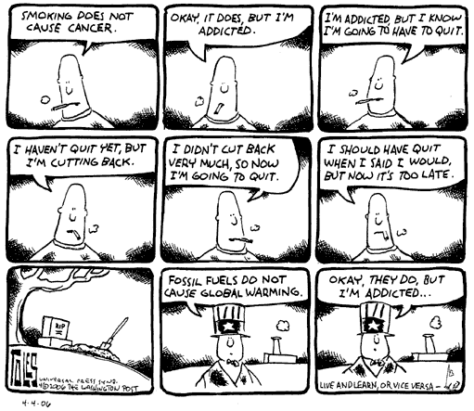

**11**

|  |
| --- |
| **CARTOON 11.** This cartoon makes an analogy (comparison between 2 situations). What is the analogy? |
|  |
|  |
|  |
|  |
|  |
| What is the cartoon suggesting will happen if we delay on climate change? |
|  |
|  |
|  |
|  |
|  |
|  |
|  |
|  |
|  |
|  |
|  |

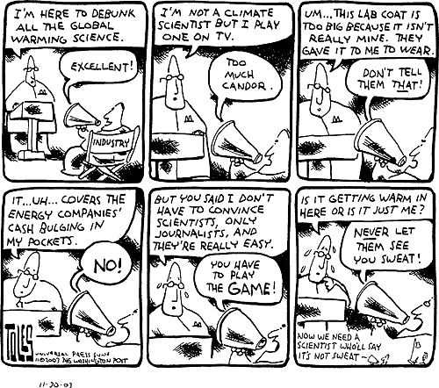

Cartoons 12 & 13 suggest that you shouldn’t believe all you hear. Why is it in some groups best interests to deny climate change?

**12**

|  |
| --- |
|  |
|  |
|  |
|  |
|  |
|  |
|  |
|  |
|  |
|  |
|  |
|  |
|  |
|  |
|  |
|  |
|  |
|  |
|  |
|  |
|  |
|  |
|  |
|  |
|  |
|  |

**GLOBAL WARMING... CAN YOU BELIEVE ALL YOU HEAR?**

How would you go about deciding who to believe and who not to?

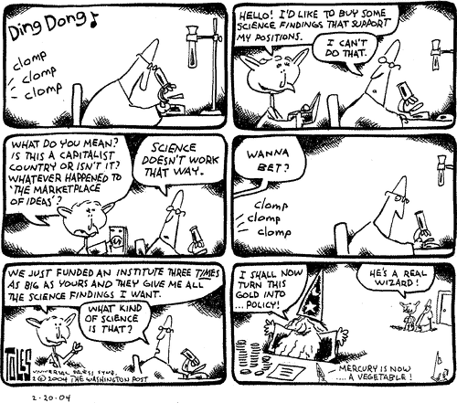

**13**