NAME: __________________________________

“Wise 18-year-old Kat gives her 16-year-old sister some worldly advice: 'Not all experience is good, Bianca.’ ”
Film study
When we study films we usually focus on the following aspects:

- purpose & audience
- plot
- characters
- setting/context
- themes
- film techniques
- language/style/symbolism
- author’s views & values

Big ideas:
- Writers create characters with flaws.
- What is popular is not always right. What is right is not always popular.
flaw = something unfavourable
Purpose & Audience
- Audience: Who do you think this movie is targeted at? What age group? What gender?
- Purpose: What are the main purposes of the film? Think about messages the movie is sending, but also think about why film makers make movies.
Plot:
- Who were the MAIN characters and what are the MAIN things that happen to them? (This question tests your ability to summarise – leave out minor details, but make sure to include all MAIN details)
Characters
- Use the word bank to list as many words as you can that apply to each of the characters below. Circle main if you think the movie is mainly about them. Circle secondary if you think they are just in the movie to help the story along.
arrogant (stuck up) |  |  | vain (overly concerned with appearance) |  | ambitious (wants to move up in the world) |  | scary
intelligent |  |  | vapid/shallow |  | loyal |  | disloyal
caring |  |  | kind |  | persistent |  | heartless
follower | creative |  | clever |  | strict |  | shy
extroverted (likes being the centre of attention) |  |  | introverted (doesn’t like being the centre of attention) |  | wise | confident | experienced
inexperienced/innocent/naïve |  |  |  | hostile | independent (makes own decisions – is not overly influenced by being accepted by others)
open-hearted |  | suspicious of others |  |  | humorous |  |  | daring

JOEY: MAIN/SECONDARY
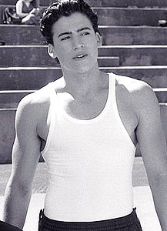

BIANCA: MAIN/SECONDARY

CHASTITY: MAIN/SECONDARY

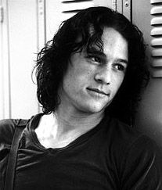
PATRICK: MAIN/SECONDARY

CAMERON: MAIN/SECONDARY

MICHAEL: MAIN/SECONDARY

DAD: MAIN/SECONDARY

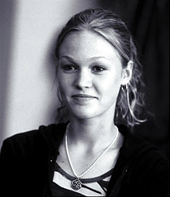

KAT: MAIN/SECONDARY

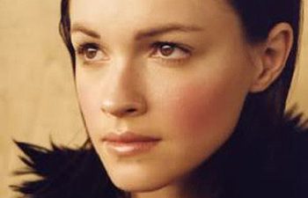
MANDELA: MAIN/SECONDARY

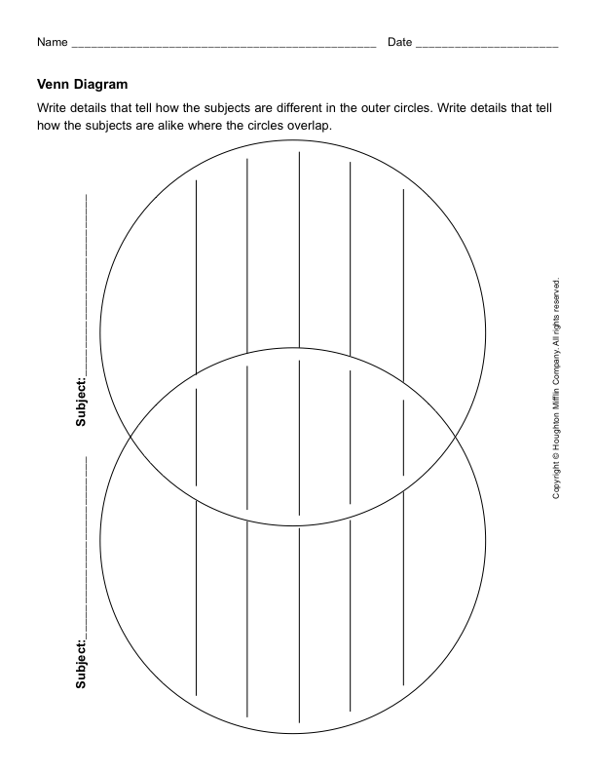
- Choose two key characters to compare and contrast. Don’t put in obvious things that a five-year-old would pick up on (like they’re both girls, she’s tall). Put in things that analyse their personalities, their attitudes to things like dating, being popular, their image, reputation…

Setting/Context & Language/Style
- What country and time period is this story set in? How can you tell? What clues does the movie give you (Think about music, fashion, buildings, speech)
jargon: special words or expressions that are used by a particular profession or group and are difficult for others to understand

- In the following scene excerpt, the Stratford girls’ father, Walter is using contemporary American slang. He is attempting to show how much he knows about what teenagers get up to. Ironically, Bianca is the one who talks without using slang. The language of the characters also gives us clues about the time period and country. 10 Things makes use of slang and teenage jargon to make the characters believable.

Have a go translating the following into formal language:

WALTER
Got news for ya. I’m down. I’ve got the 411. And you are not going out and getting jiggy with some boy. I don’t care how dope his ride is.
BIANCA groans and leaves.
WALTER(to himself)
My mama didn’t raise no fool.

Themes:
- Themes are the ideas explored by the film – think about what issues the film focuses on and makes us think more about
eg. Don’t be who everyone else wants you to be
- Can you think of any more themes/messages of the film?

- What important lesson did Kat learn from her first experiences with Joey?
- What important lesson did Bianca learn from her experiences with Cameron? (Think about the Bogey Lowenstein party scene)
- What moral dilemma did Patrick face? (choice between right and wrong)
Film Techniques
When looking at film techniques we usually focus on things like:
  - camera shots (long, medium, close-up, extreme close-up, low-angle, high-angle)
  - camera movement (pan, crane, zoom in, zoom out)
  - light/darkness
  - music/sounds
- We will now re-watch the opening scene of the movie, looking at those aspects mentioned above.
Symbolism
- In this film what are the teenager’s choice of clothes a symbol of? There could be more than one answer for this. (Think about why we choose the clothes we choose)
- When Patrick gives Kat the guitar at the end of the movie, what has the guitar become a symbol of? (Think about who gave the guitar and why it was given)
- How is Kat’s choice of music a reflection of her personality?
- The prom dance was seen by most students as a time for fun, celebration, dating and popularity, but because it often required a girl to wait to be asked by a boy to go to the dance, what did Kat see the prom dance as a symbol of?
Author’s Views & Values
In the case of a film the author is typically a combination of the writer and director. Each of these people play a large role in the kind of movie that is being made.
- In the Shakespearean version The Taming of the Shrew, Katharine’s (Kat) character not only falls madly in love with Petruchio (Patrick), but stops being a fiery personality and becomes the most obedient wife of them all! Why might the writer of the film have made Kat keep her fiery personality?

(From a review by Philip French)

