‘Discovery’ of Australia
NAME: ______________________
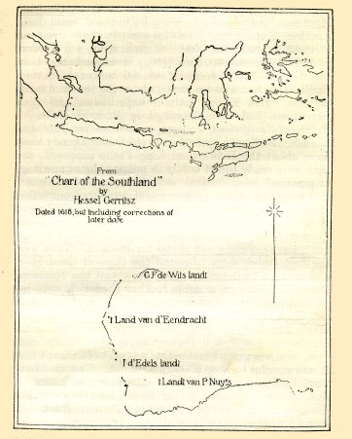
Prior Knowledge
- What do you know about who discovered Australia and how it was discovered?

Age of Exploration
- Why did Europeans of the 1300-1400s think there was another large land mass yet to be discovered in the southern hemisphere?

- What was the Treaty of Tordesillas, when was it made, and who made it?
What?

When? Who?
- Why were European sailors of the 1400s too scared to sail too far out to sea, away from land?

- Why were the Chinese sailors too scared to sail too far out to sea, away from land?

The Portuguese
- What is the Mahogany Ship mystery?

- Aside from the Mahogany Ship, what other evidence is there that the Portuguese were the first Europeans to ‘discover’ Australia?

The Dutch
- Name at least three Dutch explorers to have mapped parts of Australia in the 1600s.

- What does the mutiny of the Batavia tell us about what was happening in travel and trade in the early 1600s?

The English
- Which English buccaneer traveled around the west coast of Australia in 1688 and 1699 in ships called the Cygnet and the Roebuck?

- What were Captain James Cook’s instructions for his first voyage of 1768-1771?

- Which coast of Australia did Cook sail up and map?

- What was the name of Cook’s ship?

- Name the famous biologist on Cook’s ship who officially suggested Australia would be a good convict colony.
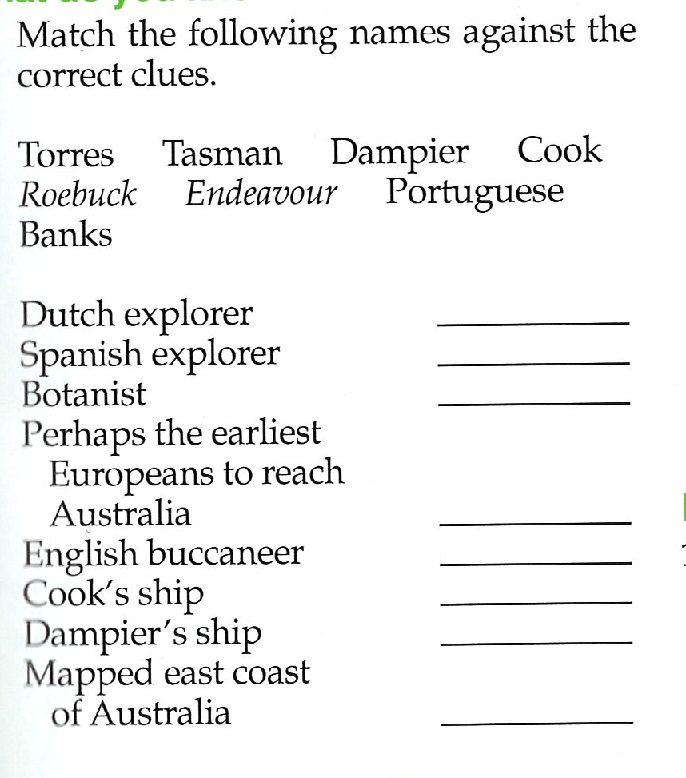

Homework: Write a paragraph that outlines the various ethnic groups believed or known (from primary sources) to have ‘discovered’ Australia.

