NAME: ________________________
Autobiographical Excerpts
Learning Intention: To be inspired by good writing! Be able to identify good writing techniques such as word choices, characterisation and use of dialogue and use these techniques in your own writing.
Mrs Pratchett

From Boy by Roald Dahl

Her name was Mrs. Pratchett. She was a small skinny old hag with a moustache on her upper lip and a mouth as sour as a green gooseberry. She never smiled. She never welcomed us when we went in. By far the most loathsome thing about Mrs. Pratchett was the filth that clung about her. Her apron was grey and greasy. Her blouse had bits of breakfast all over it, toast-crumbs and tea stains and splotches of dried egg yolk. It was her hands, however, that disturbed us most. They were disgusting. They were black with dirt and grime. They looked as though they had been putting lumps of coal on the fire all day long. The mere sight of her grimy right hand with its black fingernails digging an ounce of Chocolate Fudge out of the jar would have caused a starving tramp to go running from the shop.

Annotate this piece with examples of:
- short sentences
- adjectives
- alliteration
- things that are disgusting
YOUR TURN
Create your own version of the first few sentences with your own character or person you know/knew. Use the table below for your draft.
Her name was Mrs. Pratchett.
Her/His name was
She was a small skinny old hag
He/She was a [adjective, adjective, adjective, noun]
with a moustache on her upper lip
with a [distinguishing feature]
and a mouth as sour as a green gooseberry.
and a as as a [select one part of them
and use a simile for comparison]
She never smiled.
He/She never/always
She never welcomed us when we went in.
He/She never/always

Get a peer to edit your work and give feedback for improvement. Have it checked by the teacher. Revise your work based on the feedback and do a good copy below. DUE: _____________________

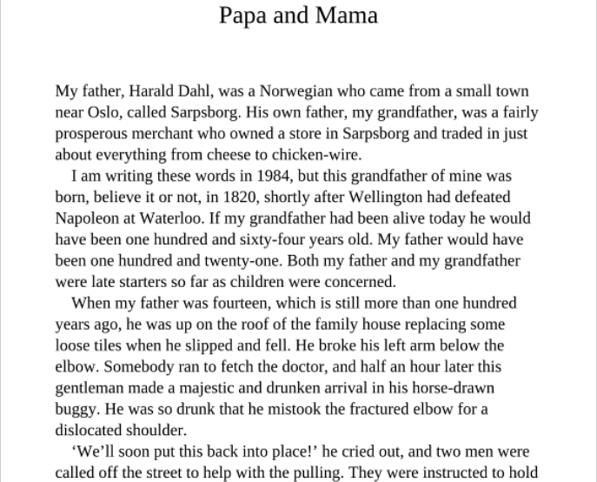
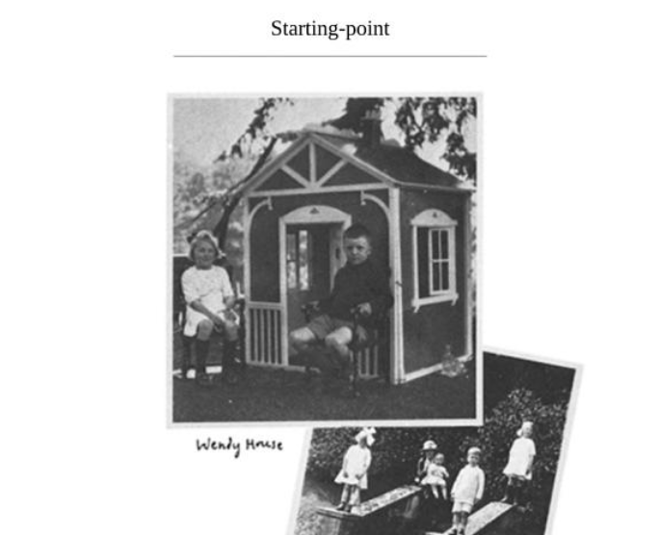

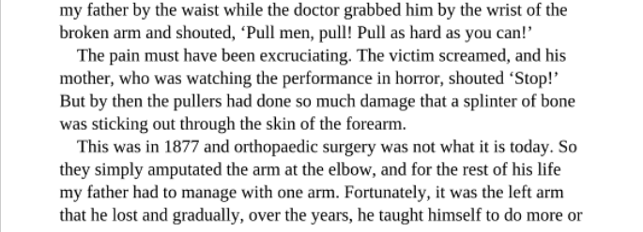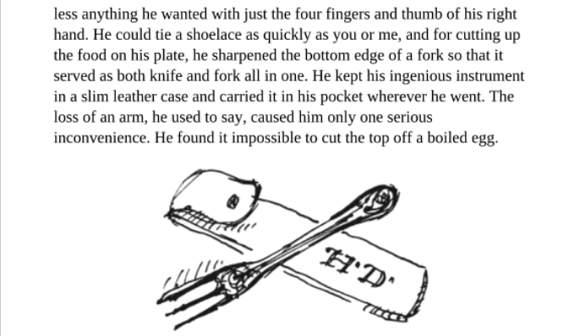

Boy, by Roald Dahl
Answer the following questions in full sentences
- Find these words and highlight them:
  - prosperous
  - fetch
  - majestic
  - excruciating
  - ingenious
Now write your own sentences using these words. You may use a dictionary to help with the meaning.
- Find the two examples of dialogue. How does this help bring the narrative to life?
- Thinking about the structure of a true narrative –
  - what does Roald Dahl chose to focus on at the beginning to introduce the story?
  - Why is the last sentence a good way to end the true story?
- Bringing real characters to life –
  - What do we learn about the doctor? How is he described and how does Dahl get across the kind of person he is?
  - What do we learn about Dahl’s father? How does he deal with the situation afterwards and what does this tell us about the qualities he has as a person?
YOUR TURN
- Write a short true narrative about one of the following:
  - a time you, or someone you know, got hurt
  - a person or place that really stands out in your memory
  - school experiences

NAME: _____________________________
AUTOBIOGRAPHICAL PIECE – HOW AM I GOING ? ASSESSMENT
How am I going? Self Assessment:
 | Perspiring and Inspiring! | Working Hard! | On Track! | Needs attention
Length | More than 220 words | Between 120-220 words | Between 80-120 words | Less than 50 words
Using Dialogue | Dialogue woven smoothly into the story and helps the reader to understand the person. | Dialogue helps us understand the person. | Dialogue present | No dialogue
Describing People and brining them to life | Three (+) of the following  unique description  simile or metaphor used,  action reveals character, what others say about them, thoughts, feelings, actions | Two (+) of the following:  general description,  what others say about them, thoughts, feelings, actions | One of the following:  general description,  what others say about them, thoughts, feelings, actions | No character description or detail.
Word Choice | Four or more examples of deliberate use of POWERFUL verbs, specific nouns, adjectives, adverbs, similes, metaphors, etc | Three examples of deliberate use of STRONG verbs, specific nouns, adjectives, adverbs, similes, metaphors, etc | Two examples of deliberate use of verbs, specific nouns, adjectives, adverbs, similes, metaphors, etc | No stand out verbs, nouns, adjectives, adverbs etc.
Spelling, punctuation | Editing is shown in a different colour and only 1 or 2 spelling or punctuation errors. Starting to use other punctuation such as ! - : ; ( ) | Editing is shown in a different colour and only a few full stop, question mark or capital letter errors. | Editing is shown in a different colour. Needs attention on one or more of:  full stops  ? “ “ capital letters, apostrophes | No attempt to edit in a different colour.
One thing I did well was:

Two things I will work on for my good copy are:

1.

2.

Signed: Teacher:

