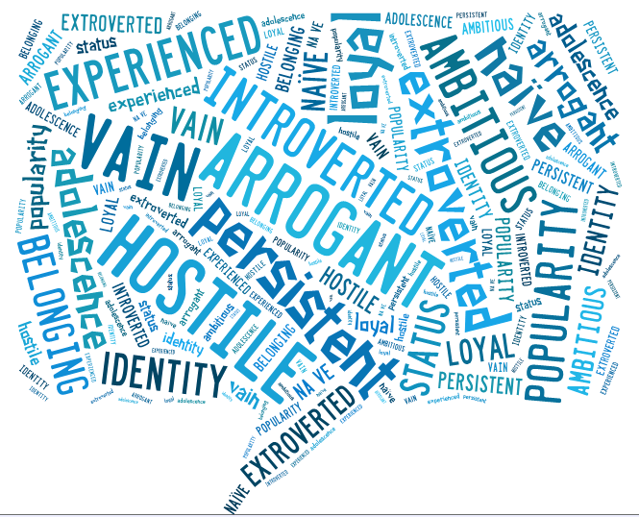
NAME: ______________
10 Things I Hate About You
Key vocabulary
Learning Intention: Apply an expanding vocabulary to read increasingly complex texts with fluency and comprehension.
Metalanguage
long shot, medium shot, close-up, high-angle, low-angle, jargon, slang, secondary character, themes, symbolism
Content Vocabulary
hostile, arrogant, vain, persistent, loyal, naïve, extroverted, introverted, experienced, ambitious, popularity, adolescence, identity, belonging, status
1. Match the words in the box below to their opposites
hostile arrogant loyal extroverted experienced
disloyal
introverted
naïve
friendly
humble

2. Place the box words into sentences:
1. She was quite _____________________________ ; she didn’t speak up much in groups.
2. He was quite _____________________________ ; he loved being noticed and talking loudly so others would listen.
3. He was a _____________________________ man: although he had achieved amazing things, he didn’t brag.
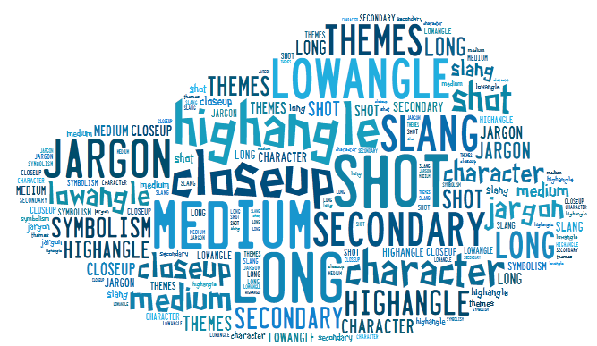
4. He was quite an _____________________________ man: he believed he was better than everyone around him.
5. She was incredibly _____________________________ to think that no one would lie to her.
6. She was _____________________________ and knew that people lied all the time.

3. Match the metalanguage vocabulary to their meanings
long shot, medium shot, close-up, high-angle, low-angle, jargon, slang,
secondary character, theme, symbolism

when an act, image, object or place represents something much bigger than itself, usually an abstract idea like friendship, love. For example, when a dove is used to represent peace.
camera shot where the camera is high, angled down towards the subject. Often used to make the subject look weak or vulnerable.
specialist language: language that is used by a group, profession, or culture, especially when the words and phrases are not understood or used by other people

camera shot of distant object: a camera shot taken some distance from the object or scene
an idea that is being explored in a text, such as love, belonging, the challenge of adolescence…
camera shot where the camera is low, angled up towards the subject. Often used to make the subject look more powerful.
view between long shot and close-up: a filmed view, midway between long shot and close-up, that shows a standing person from the waist up or the full body of a sitting person
minor characters; characters who don’t have a main role, but more of a supporting role in the plot/storyline.
camera shot of something up close: usually a head shot down to the shoulders. Used to show characters’ emotions and reactions.
very casual speech or writing: words, expressions, and usages that are casual, vivid, racy, or playful replacements for standard ones, are often short-lived, and are usually considered unsuitable for formal contexts

Metalanguage is the words we use to talk about language that writers and film makers use. Eg ‘long shot’ ‘symbolism’ ‘metaphor’

